**Form of information submitted when applying for de minimis aid other than in agriculture or fisheries, or de minimis aid in agriculture or fisheries**

**Filling instructions**

**Section A. Information on the entity to which State aid is to be granted**



**Item 1** Enter your data as an entity that applies for aid, i.e. NIP (TIN) or other registration number (for entities that do not have a NIP number). The identifier should be consistent with that provided in the applications for aid.

**Items 2 and 3** The name and registered office of the entity should be in accordance with the registration documents in your country. If aid is requested by a partner of a civil, general or commercial partnership, or a general partner of a limited partnership or limited joint-stock partnership who is not a shareholder, in connection with the activities carried out in the partnership, the information regarding the partnership should be provided in item A of the form. In the case of a civil partnership, the NIP (or other registration number of that partnership), the name under which the partnership operates in the market and the place of business, and if there is no name and place of business, the names and addresses of all partners in that partnership should be provided.

**Item A 1.** - **to be completed only by Polish applicants** - enter the data of the partner of the enterprise or the general partner in connection with the activities carried out by the partner in the enterprise. E.g., a civil partnership applies for aid in the form of relief or exemption from property tax while only one of the partners of the partnership is the owner of the property or tax payer. In such a situation, in item A we enter the data of the enterprise while in item A1 we enter the data of the partner who took advantage of the tax law relief (which is important for tax offices).

**NOTE**: in most cases, recipients of state aid, including enterprises, receive aid in the form of grants, but not in the form of tax exemptions. In such a situation the data are filled in only in item A.



**Item 4 -** **to be completed only by Polish applicants** - enter the identifier of the municipality in which the entity has its residence or office. Enter the full seven-digit identifier of the municipality in whose area you reside or have a n office. The current [list of identifiers of municipalities](https://uokik.gov.pl/sporzadzanie_sprawozdan_z_wykorzystaniem_aplikacji_shrimp.php#faq1944) can be found at on the Office of Competition and Consumer Protection (OCCP) website in the *Files to help with reporting and instructions* section.

Item **5** - mark the correct item with an X. If you mark 'other', indicate - in the box below this answer - what legal form it is, e.g. civil partnership, association, foundation.

**Applicants from outside Poland** - in the case of legal form, indicate the form that is most similar to the legal forms in your country.



Item **6** mark the correct item with an X. If you are not a SME, mark X as other enterprise.

The criteria for qualifying an enterprise as a micro, small or medium-sized enterprise (SME) are set out in Annex I to Commission Regulation (EU) No. 651/2014 of June 17, 2014 declaring certain types of aid compatible with the internal market in application of Articles 107 and 108 of the Treaty.

When determining SME status, the explanations in the document issued by the European Commission will be helpful:

[User's guide to SME definition](https://op.europa.eu/en/publication-detail/-/publication/756d9260-ee54-11ea-991b-01aa75ed71a1/language-en/format-PDF/source-293817907)

The concept of an enterprise and economic activity is explained in the Commission's Note on the concept of state aid as understood in Article 107(1) of the Treaty on the Functioning of the European Union (2016/C 262/01).

An entrepreneur within the meaning of state aid is any entity that performs economic activities regardless of its legal form and method of financing. Therefore, entrepreneurs can be both public and private entities, e.g. associations, foundations, a museum, a local government unit, organizations that conduct research and disseminate knowledge (e.g. a university, a research institute) to the extent that they carry out economic activities involving offering goods and services on the market.



**Item 7** - enter the class of activity with reference to which you are applying for aid. If it is not possible to determine one such activity, provide the Polish Classification of Activities PKD or NACE class of that activity that generates the largest portion of revenues. Enter the appropriate PKD /NACE class and enter its format without a period, such as 8560.

**NOTE:** if you have more than one PKD code, provide the code for the business activity for which you are applying for aid. [List of PKD classes](https://uokik.gov.pl/sporzadzanie_sprawozdan_z_wykorzystaniem_aplikacji_shrimp.php#faq1944) can be found on the Office of Competition and Consumer Protection (OCCP) website in the *Files to help with reporting and instructions* section. NACE classes are governed by Regulation (EC) No. 1893/2006 of the European Parliament and of the Council of December 20, 2006 on the NACE statistical classification of economic activities Rev. 2 and amending Council Regulation (EEC) No. 3037/90 and certain EC regulations on specific statistical domains (OJ L 393 of December 30, 2006, pp. 1-39) [consolidated act](https://eur-lex.europa.eu/legal-content/PL/TXT/?uri=celex%3A02019R2152-20220101).

**Item 8** - enter the start date of activity with reference to which you are applying for aid.



**Item 9** - answer the questions in subsections 9a through 9f. If you check at least one answer in the affirmative, then provide the tax ID of the NIP or other registration number of all entrepreneurs related to you (you do not enter your data because they have already been given in item A). In case of affiliation with foreign enterprises, indicate the country-specific enterprise identifier. Along with the NIP or other registration number, provide the name of the related entrepreneur.

**NOTE:** entities with a complex structure, which consist of many interrelated units with separate legal personality, must be treated as a single economic organism. All entities that are controlled (legally or de facto) by the same entity should be treated as one enterprise.

**Section B. Information on the economic situation of the entity to be granted state aid** 

**NOTE: Part B of the form shall not be completed in the case of entities to which aid is to be granted on the basis of Article 34a of the Act of May 8, 1997 on Warranties and Guarantees issued by the State Treasury and certain legal entities (JO of 2012, item 657, as amended).**

**Items 1-5** mark the answer “yes”, no or “not applicable”.

**Items 1 and 2** mark “not applicable” if you are a micro, small or medium-sized enterprise referred to in Annex I of Commission Regulation (EU) No. 651/2014, and:

* you have been in business for less than 3 years from the date of the establishment of the business activity to the date of your application for aid, or
* you apply for aid under the terms of Article 21 of Commission Regulation (EU) No. 651/2014 within seven years from the date of the first commercial sale, which are eligible for risk financing investments following due diligence by the selected financial intermediary.

**Item 1** the amount of uncovered losses exceeds 50% of the amount of registered capital, if after subtracting the value of accumulated losses from the sum of capitals of a reserve nature (such as supplementary capital, reserve and revaluation reserve) you get a negative result, the absolute value of which exceeds half of the value of registered capital, i.e. share capital.

**Items 3 and 4** choose a “yes” or “no” answer. These questions apply to all entrepreneurs regardless of their legal form and start date of activity.

**Item 5** select the answer “yes“ or “no“ if you are an enterprise other than SME.

**NOTE:** any answer in the affirmative in items 1-5 means that you are an enterprise in a difficult situation, in this situation you cannot receive the state aid you are applying for. Alternatively, you should apply for restructuring aid.

**Item 6** do not complete. It is filled out only in the case of other forms of aid, such as loans, guarantees, deferrals, installments to determine the reference rate, that is, the borrowing capacity of the entrepreneur (the value of the reference rate is equal to state aid. If the answer is affirmative then help can be provided).

**Item 7** mark the answer “yes“ or “no“ if you have shown related parties in Item 9 in Section A. You assess the economic situation of related parties based on the premises specified in items 1 through 5 in Section B. If you did not show related party relationships in item 9 in Section A because you answered “no“ to all questions, then select “not applicable“ in item 7 in Section B.

**SECTION C. Information on the decision of the European Commission imposing an obligation to return the state aid granted**



Mark the correct item with an X. The obligation to repay the granted aid, which results from the decision of the European Commission, may apply to you as an entrepreneur who applies for funding, as well as to any related enterprise. As long as the aid, resulting from the European Commission's decision, has not been repaid, you cannot receive new state aid.

**SECTION D. Information on economic activity conducted by the entity to be granted state aid** 

**Items 1a to 1j, 2 -** listed sectors for which aid is excluded or the limit is different from Regulation 651/2014. Depending on the purpose of the aid and the nature of the entrepreneur's activities, the exemption may or may not apply. An affirmative answer does not preclude the granting of aid. Comparisons are made between the exclusion data and the actual conditions of the aid that is provided.

**Item 3** If the activity is carried out in the excluded sector but accounting separation is maintained, the aid can be granted. **Accounting separation of** a specific business activity involves keeping separate records for that business activity and properly allocating revenues and expenses on the basis of consistently applied and objectively justifiable methods. Accounting separation is defined in the relevant country's accounting regulations.

**Item 4 -** indicate the information that relates to the project for which you are applying for aid.

* **a description of the project, including its planned start and end dates** - enter briefly the activities implemented under the project, provide the reporting period resulting from the grant application. In particular, a project should be understood as a project that involves an investment, activity or service of general economic interest.
* **location of the project** - indicate the address of your residence or the address of the headquarters of the entity you represent;
* **a list of project costs and their nominal and discounted values** - indicate the amount of your part of the project budget.

**NOTE:**

1. You do not need to describe in detail the activities carried out under the project. You can enter the number and name of the project in which the investment, activity, service was described.
2. Do not complete **item 5 in D section**. This section of the form does not apply to the aid for which you are completing the form.
3. Remember that the information specified in Section D, item 4 of the form relates to the project for which you are applying for aid and submitting the form. So you present information that relates to the INTERREG project funding. On the other hand, in Section E, item 8 of the form, you show what aid you have already received for this project from other sources, that is, what aid you have received in relation to the cost of the project.

**SECTION E. Information on the aid received**



**Item 1 -** indicate a 'yes' answer if you have received aid from other sources for the cost of the project for which you are submitting this form. However, if you have not received aid from other sources for your project activities then indicate the answer 'no'.

**Item2 -** indicate the answer 'yes', because the aid will be allocated to identified costs, i.e. costs incurred under the project, even if they are incurred under simplified costs.

**Item 3** - indicate the answer 'yes' if you have received other aid for the same costs, such as in the form of a national grant or, for example, aid in the form of relief or installment in an investment that was initiated before the project.

**Item 4** - **to be filled out only by Polish applicants** - indicate the answer 'not applicable'. This item does not apply to the aid for which you are completing the form.



**EXAMPLE OF FILING in accordance to the instructions below:**

|  |  |  |  |  |  |  |  |
| --- | --- | --- | --- | --- | --- | --- | --- |
| **Date of aid** | **Granting entity** | **Legal basis for granting the aid** | | **Purpose of the aid** | **Form of aid** | **Value of aid received** | |
| **Basic information** | **Detailed information** |  | **nominal** | **gross.** |
| **1** | **2** | **3a** | **3b** | **4** | **5** | **5b** | **6** |
| October 1, 2023 | Ministry of Development Funds and Regional Policy, (Managing Authority for the INTERREG programme) | Act of April 28, 2022 on the principles of implementation of tasks financed from European funds in the financial perspective 2021-2027, Article 30 paragraph 4 | SA.111014  Regulation of the Minister of Development Funds and Regional Policy on the granting de minimis and State aid under the Interreg programmes for 2021-2027 (OJ 2022.2755 and OJ 2023.2502), Agreement No. ............ of January 10, 2023 concluded between the Minister of Development Funds and Regional Policy and ..................(name of a beneficiary) | A25 | A.1.1 | 1,200,000 | 1,200,000 |

**NOTE:** Item 5 takes into account state aid and any de minimis aid received for the same costs for which the requested state aid is to be used, regardless of the country in which the entity that granted the aid is located.

Complete the table **in item 5** if you marked 'yes' to items 1 and 3 in section E.

**In Column 1** Date of aid (Col. 1) - enter the date of conclusion of the agreement between the entity providing aid and the entity applying for aid, or in the absence of an agreement, the date of actual benefit (e.g., the day of participation in training, the day of participation in a trade fair). In the case of de minimis aid, the date from the certificate should be given. Provide information on aid received for the same project for the implementation of which the applicant is applying for state aid, or rescue, restructuring or temporary restructuring aid. For example, if the applicant has received aid in the past for investment, only aid for the same eligible costs for which the requested aid is to be provided should be shown.

**In column 2**, in the case of state aid, provide data from the agreement. In the case of de minimis aid, provide data from the de minimis aid certificate.

**In column 3a**, enter the date and name of the act along with the corresponding provision number of that law (Ex: Act of April 28, 2022 on the principles of implementation of tasks financed from European funds in the financial perspective 2021-2027, Article 30 (4)) should be provided in the following order: date and title and designation of the year (number) and position of the Journal of Laws in which the Act was published, and designation of the provision of the Act which is the basis for the provision of aid (in order: article, paragraph, point, letter, indent).

**In column 3b** , enter the date and name of the regulation with the name of the publisher. If there is an agreement, the number, date, parties and subject of the agreement should also be provided. If there is no agreement, be sure to write the word "NONE” e.g.: Regulation of the Minister of Development Funds and Regional Policy on the granting de minimis and State aid under the Interreg programmes for 2021-2027 (OJ 2022.2755, OJ 2023.2502) and agreement number .........., dated ......., concluded by and between: Subject Matter of the Agreement .................................... OR the word "NONE" if there is no agreement.

In the absence of an implementing act as a legal basis for the provision of aid, insert "none". If the basis for providing aid was a decision, resolution or agreement the symbol identifying this act should be given; in the case of a decision - the number of the decision, in the case of a resolution - the number of the resolution, in the case of an agreement - the number of the subject matter and the parties to the agreement. In the absence of a decision, resolution or agreement that is the legal basis for the provision of aid, insert "none”.

**In column 4**, enter only the code indicating the form of aid from the "Form of Aid" table, e.g.: A1.1 - grant and other non-refundable benefits, A1.4 - reimbursement, etc.

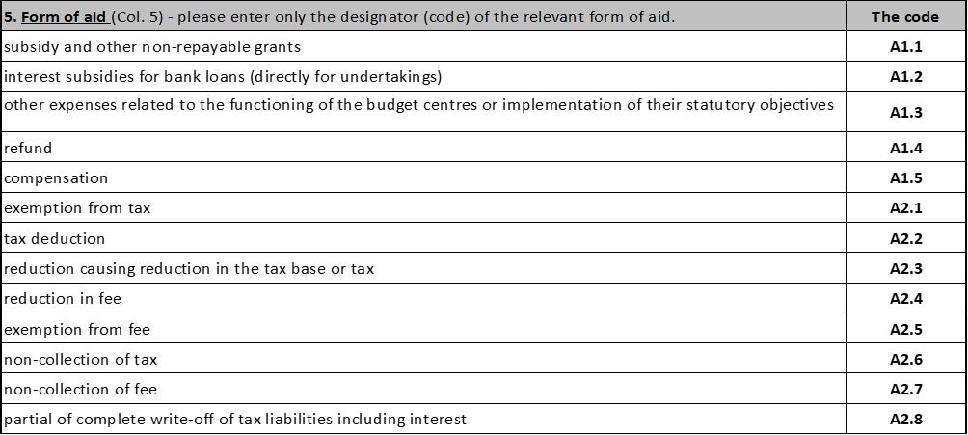

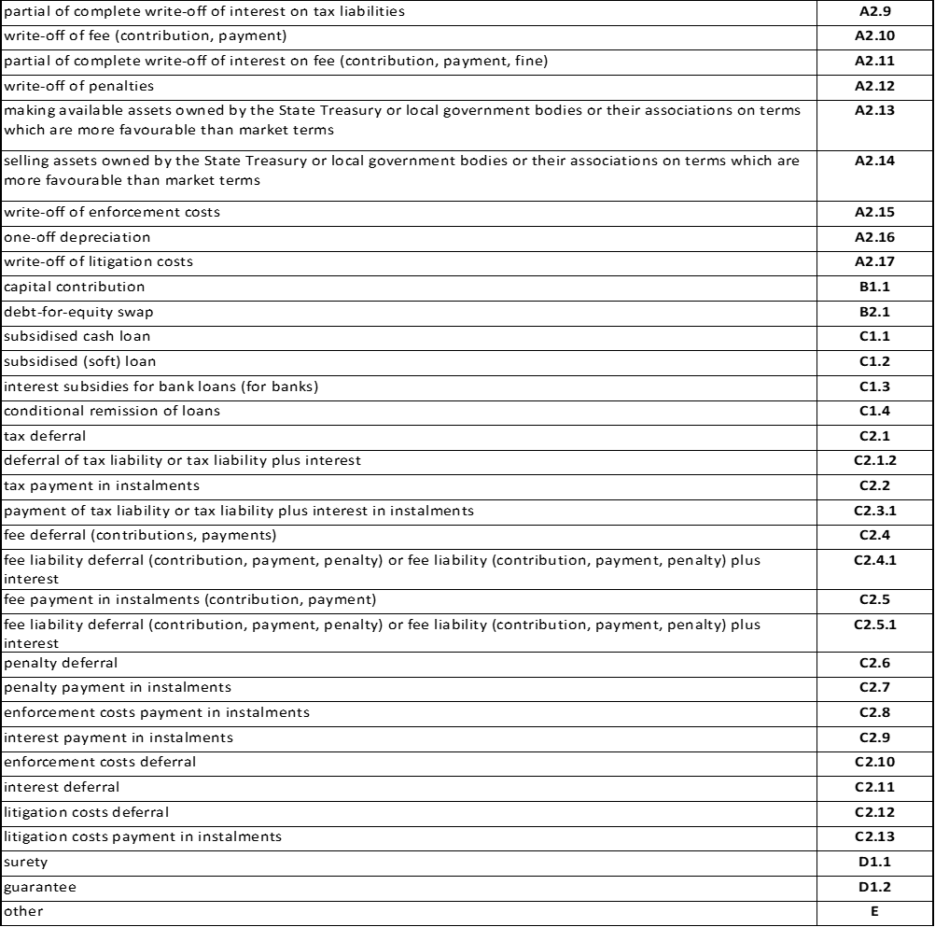

**In column 5a and in column 5b**, enter in EUR the value of aid from the agreement or other document, from which the value of the aid arise. In the absence of an agreement or other document, the value of the actual grant must be given. In the case of a form of aid other than a grant, its value should be given as a grant equivalent calculated in accordance with the relevant EU regulations. In the case of the value of the aid determined in a currency other than EUR, the value of the aid in EUR shall be calculated in accordance with the average EUR exchange rate in effect on the day the aid is granted, as announced by the Central Bank of the country in which the applicant is located.

**In column 6** enter the code indicating the purpose of the aid from the table "Purpose of state aid", e.g.: e1 - de minimis aid, a25 - aid for participation in projects within the framework of European Territorial Cooperation granted on the basis of Article 20 or a.25.1 in the case of granting aid under Article 20 a. Other uses of the aid are permissible as long as it is provided for in the programme.

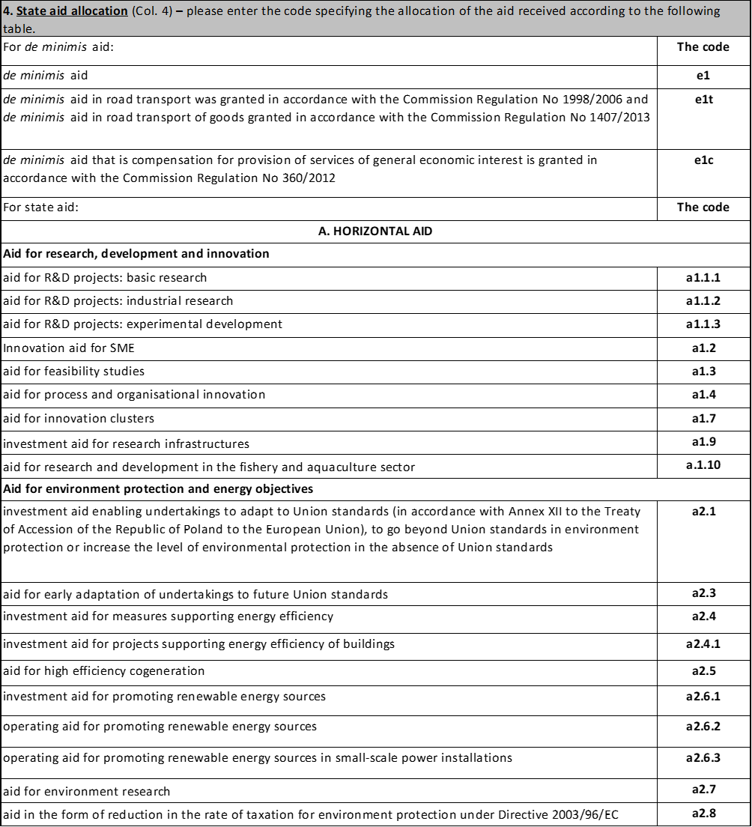

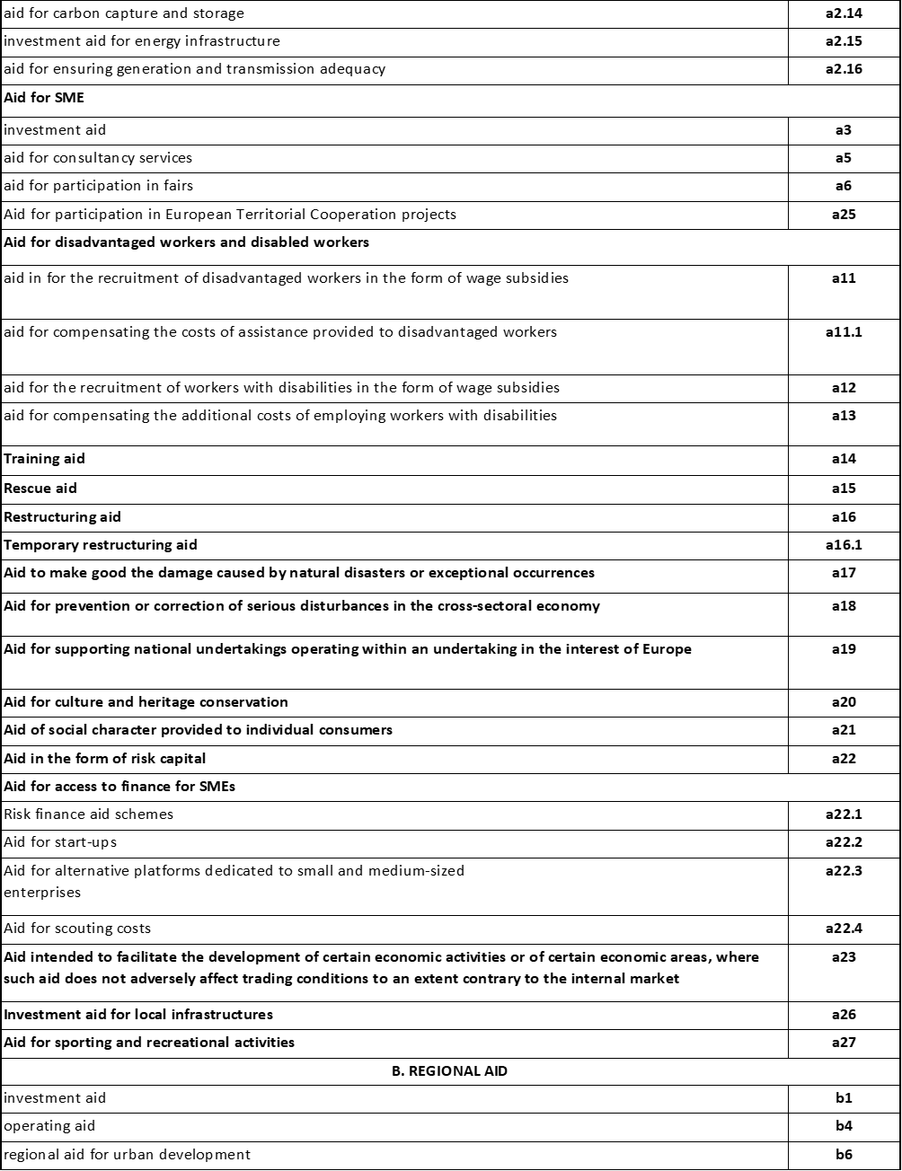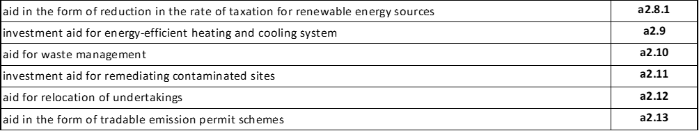

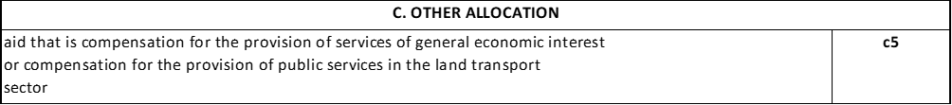

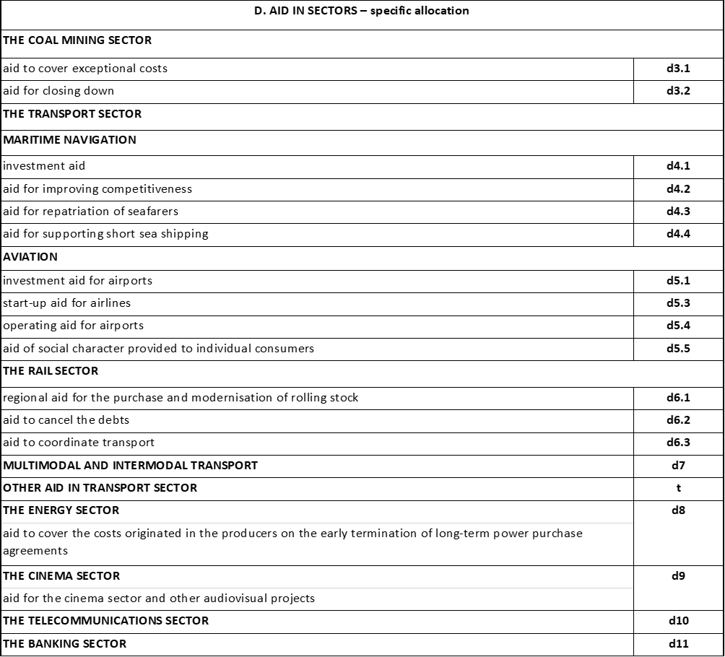

|  |  |  |  |  |  |  |  |  |  |  |  |  |  |  |  |  |  |  |  |  |  |  |  |  |  |  |  |  |  |
| --- | --- | --- | --- | --- | --- | --- | --- | --- | --- | --- | --- | --- | --- | --- | --- | --- | --- | --- | --- | --- | --- | --- | --- | --- | --- | --- | --- | --- | --- |
| **6. In the case of applying for aid for the following purposes:** | | | | | | | | | | | | | | | | | | | | | | | | | | | | | |
|  | **a) for participation of micro-, small and medium-sized enterprises in fairs (Article 19 of Commission Regulation (EU) No. 651/2014),** | | | | | | | | | | | | | | | | | | | | | | | | | | | | |
|  | **~~(b) in the form of subsidized remuneration for the recruitment of disadvantaged employees (Article 32 of Commission Regulation (EU) No 651/2014),~~** | | | | | | | | | | | | | | | | | | | | | | | | | | | | |
|  | **~~c) in the form of wage subsidies for employment of disabled workers (Article 33 of Commission Regulation (EU) No 651/2014),~~** | | | | | | | | | | | | | | | | | | | | | | | | | | | | |
|  | **~~d) to compensate for additional costs related to the employment of disabled workers (Article 34 of Commission Regulation (EU) No 651/2014),~~** | | | | | | | | | | | | | | | | | | | | | | | | | | | | |
|  | **~~e) to compensate for the costs of support granted to employees who are in a particularly disadvantaged situation (Article 35 of Commission Regulation (EU) No 651/2014),~~** | | | | | | | | | | | | | | | | | | | | | | | | | | | | |
|  | **f) operational aid for culture and heritage preservation (Article 53 of Commission Regulation (EU) No 651/2014),** | | | | | | | | | | | | | | | | | | | | | | | | | | | | |
| **specify in EUR29) the total value of aid received by the entity applying for aid and related entities whose tax identifiers are indicated in part A point 9 during current year within the same purpose as the purpose of the aid for which it applies:** | | | | | | | | | | | | | | | | | | | | | | | | | | | | | |
|  | | | | | | | | | | | | | | | | | | | | | | | | | | | | | |
|  |  |  |  |  |  |  |  |  |  |  |  |  |  |  |  |  |  |  |  |  |  |  |  |  |  |  |  |  |  |
| **7. If applying for risk financing aid (Article 21 of Commission Regulation (EU) No. 651/2014) or start-up aid (Article 22 of Commission Regulation (EU) No. 651/2014), indicate the total value in Euro24) of the aid received by the applicant and its related entities whose tax identifiers are indicated in Part A, item 9 of the form, under the same purpose as the purpose of the aid applied for.** | | | | | | | | | | | | | | | | | | | | | | | | | | | | | |

Do not fill in items 6 and 7. They do not apply to the aid in connection with which you are filling out the form.



**NOTE:** If you have shown any aid from other sources relating to the cost of the project in the table in item 5 in Section E, then also complete items 8a through 8e in Section E. Provide information on the project for which you have received this aid.

**SECTION F. Information about the person authorized to provide information**



In Section F you indicate the data of the person authorized to provide information:

* Full name:
* Official position:
* Phone number:
* Date and signature.