**WOD2021**

**Interreg Applicant Manual**

**General Part**

as of 31 May 2023

Version 1

**List of contents**

I. WOD2021 APP 4

1.1. REGISTERING A USER 6

1.2. CREATING AN ORGANIZATION 14

1.3. EDITING AN ORGANIZATION 14

1.4. DELETING AN ORGANIZATION 18

1.5. LOGGING IN 19

1.6. SELECTING THE LANGUAGE VERSION 21

II. ERGONOMICS AND ACCESSIBILITY 22

2.1. CHANGING THE CONTRAST 22

2.2. EXTENDING A SESSION 23

III. FILTERING AND SORTING PANEL 25

IV. MANAGING USERS AND THEIR RIGHTS 29

4.1 MANAGING THE ROLES 29

4.1.1 Viewing the roles 29

4.1.1.1 Viewing the details of a role 31

4.1.2 Creating a role 33

4.1.3 Editing a role 35

4.1.4 Deleting a role 35

4.2. PROFILE MANAGEMENT 36

4.2.1. Viewing the profiles 36

4.2.1.1. Viewing the details of a profile 38

4.2.2. Creating a profile 39

4.2.3. Editing a profile 41

4.2.4. Activating a profile 42

4.2.5. Deactivating a profile 43

V. CALLS - viewing 44

5.1. VIEWING THE CALLS LIST 44

5.1.1. Viewing the details of a call 45

5.2. CALLS SEARCH 45

VI. APPLICATIONS FORMS 47

6.1. VIEWING THE APPLICATION FORMS 47

6.1.1. Viewing the details of application forms 49

6.2. CHECKING THE CORRECTNESS OF THE APPLICATION FORM 51

6.3. VIEWING APPLICATION FORM VERSIONS 52

6.4. COMPARING THE VERSIONS 54

# WOD2021 APP

The WOD2021 app allows you to prepare and submit an application form in a call for proposals announced by the Joint Secretariat or Managing Authority. The application is available at **https://wod.cst2021.gov.pl**

On entering the WOD2021 main page, you will see the following view:

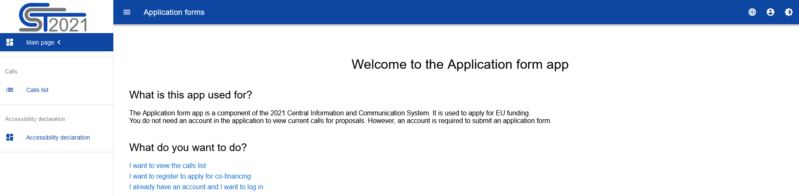

Without logging in to the app, you can:

* view announced calls for proposals,
* log in to the system,
* register in the system as an Applicant.

In addition to the ***Main page*** and ***Calls list***, the WOD2021 app always shows also the ***Accessibility declaration***:

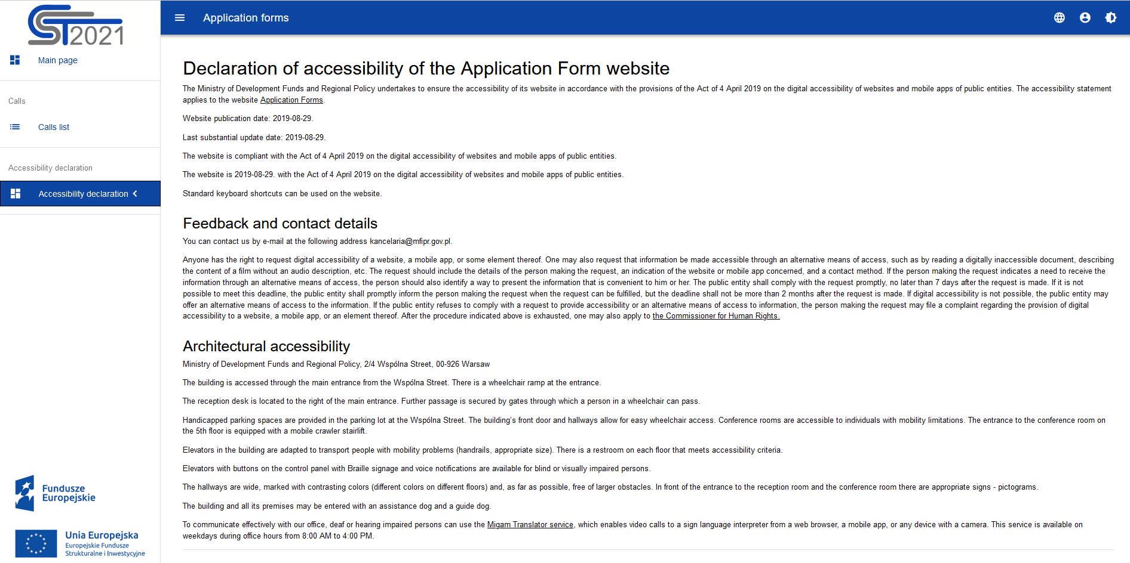

# REGISTERING A USER

**Note!**

* **The first user from a given organization who creates an account and registers organization information will automatically become its *Administrator*. This means that, among other things, the user will be the only person authorised to create roles and profiles (as referred to in Chapter IV) and assign other employees of their organization to work in WOD2021.**
* **In particular, the *Administrator* can designate another Administrator. It is very important to have at least two Administrators within one organization!**
* **Each successive person from a given organization who creates an account in the system will be notified who has the role of the *Administrator* in the organization, and thus know who to approach to be granted rights to work in the system. The *Administrator* will also be notified automatically about the registration of a new user from the organization in the system who needs to be granted suitable rights.**
* ***Important*: the registration alone of a user other than the Administrator will not allow the user to work in the system just yet. Suitable rights must first be granted by the Administrator of the system in the organization (i.e. a profile for such a user, including specific rights, must be created and activated). Organizations should define the scopes of rights for individual users.**

If you are a new user who has no account in the app yet, you must register in the system. You can do it only in the following ways:

1. by selecting the option "***I want to register to apply for co-financing***" in the main screen
2. by clicking the icon in the top right corner of the app and selecting ***Create an account***:

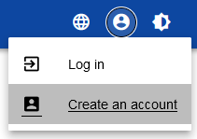

* **Please do not select Log in option if you do not have an account yet!!!**

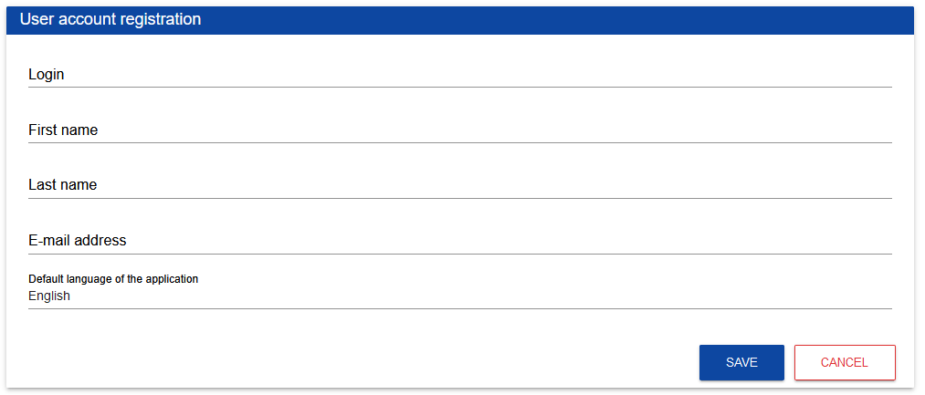

During registration, you must provide your first name, last name and e-mail address for which the account will be created. An Applicant must also suggest their login which they will subsequently use when logging in, and select the default language of the app. On logging in, you can change the language version during your active session.

The system will acknowledge the creation of an account by displaying a special message.

Automatic messages will be sent to the e-mail address given at registration to inform the user that their account has been created and provide the link to create the password.

Upon acknowledging the account registration, the system will ask the user to choose the organization:

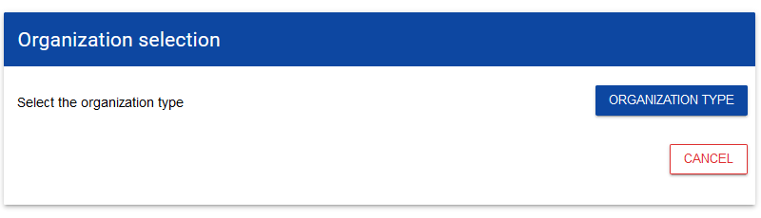

**If you are an Applicant from Poland, you must select the organization type *Domestic entity*.** When you select this option, the system will ask you to give the tax identification number (NIP) of your organization:

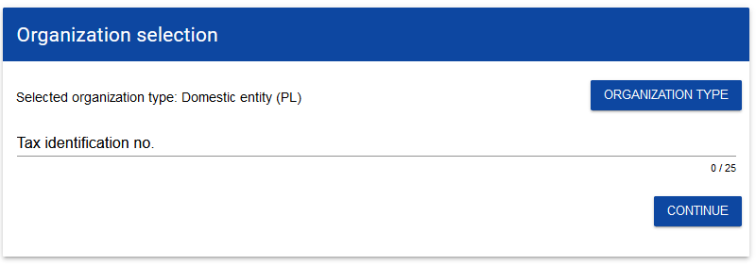

After the NIP is entered, the system will check whether an organization holding that NIP is recorded and identified in the system. **If the organization has already been registered by another user you will have to choose the organization you want to join**.

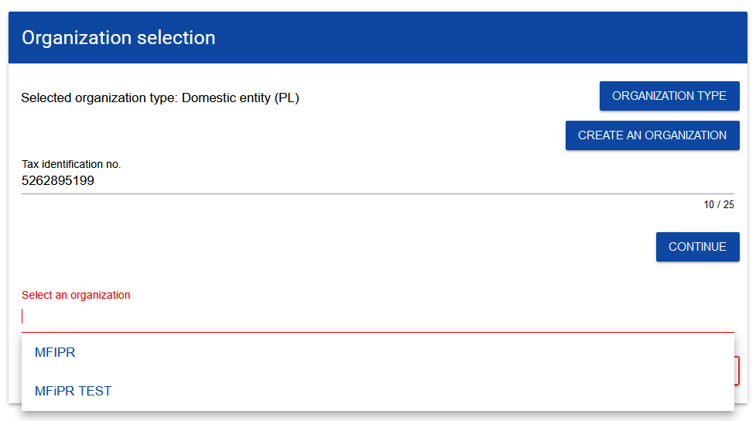

The system creates the account for you in the selected organization but it will be unactive. **The Administrator in the organization will be notified about the need to activate the account for you**, which will mean granting you specific rights to work in the system.

* **You can create the new version of the existing organization. If you are the applicant from the organization with many units implementing UE projects and working in WOD2021, we recommend to create a new version of the organization. You will become the administrator of the new organization and it will be easier for you to manage of your projects.**

If the organization has not been registered yet, the system will open a page with the form that must be filled in:

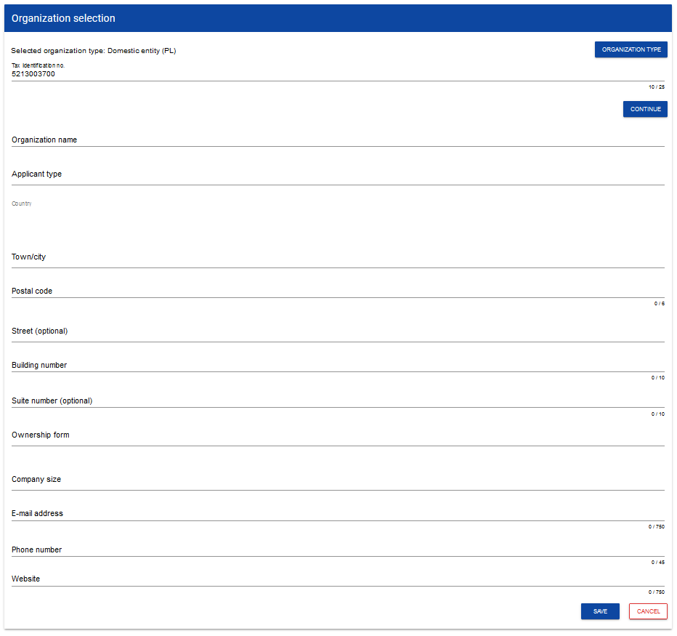

**Note!**

* **When registering your organization, do not give your e-mail address or telephone number. The data should concern your organization, and therefore include its official e-mail address and telephone number.**

After you have completed the data and clicked ***Save,*** a new domestic entity will be added in the bottom right corner of the screen. Your account will be assigned to that organization.

**If you are a foreign entity, you must select *Entity from outside Poland***. The following screen will be displayed:

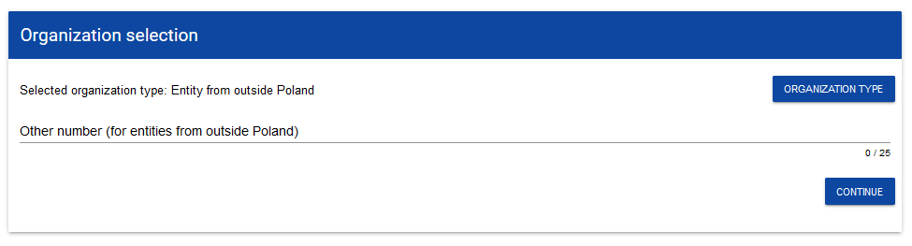

After the foreign ID number is entered, the system will check whether an organization holding that number is recorded and identified in the system.

**If the organization has already been registered by another user you will have to choose the organization you want to join**.

The system creates the account for you in the selected organization but it will be unactive. **The Administrator in the organization will be notified about the need to activate the account for you**, which will mean granting you specific rights to work in the system.

* **You can create the new version of the existing organization. If you are the applicant from the organization with many units implementing UE projects and working in WOD2021, we recommend to create a new version of the organization. You will become the administrator of the new organization and it will be easier for you to manage of your projects.**

If the organization has not been registered yet, the system will open a page with the form that must be filled in:

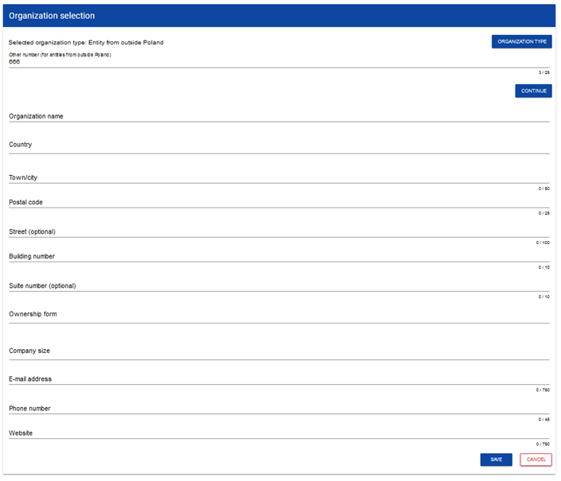

After you have filled in the fields and clicked ***Save,*** a new foreign entity will be added in the bottom right corner of the screen. Your account will be assigned to that organization.

**The option *Natural person* does not apply to Interreg programmes, as natural persons cannot apply for co-financing under those programmes!**

# CREATING AN ORGANIZATION

It can also happen that one user represents more than one organization (more than one Applicant). To proceed in such case, the option to create a new organization has been made available. To register a new organization, select ***Create an organization*** in the app menu on the left side of the screen. An identical screen will then be displayed as in the case of registering a user (see 1.1).

Further steps are the same as for creating an organization in the user registration process (see 1.1).

When a new organization is created, a new user profile will also be created. If you select that new profile and create a new application form, the application will automatically be populated with the organization details from the new profile.

**Note!**

* **Remember that if you are the first person to create an organization/version of the organization in the system, you become its Administrator.**

# EDITING AN ORGANIZATION

If the data of your organization has changed, you must update it. To this end, select ***Organizations list*** in the app menu on the left of the screen. A screen with all the user's organizations will be displayed:

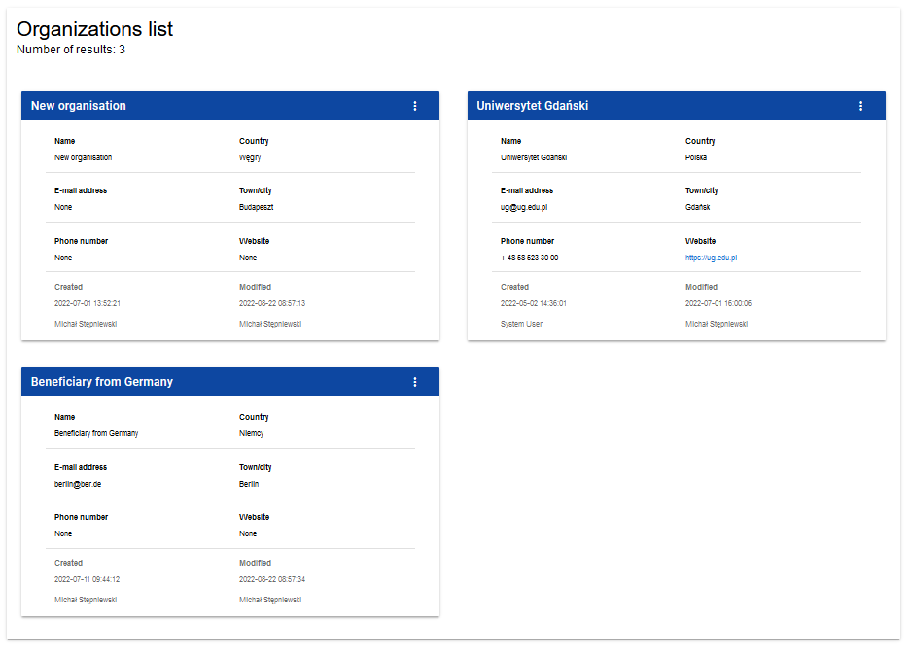

Next, select ***Edit an organization*** in the menu of the selected organization in the top right corner of its card:

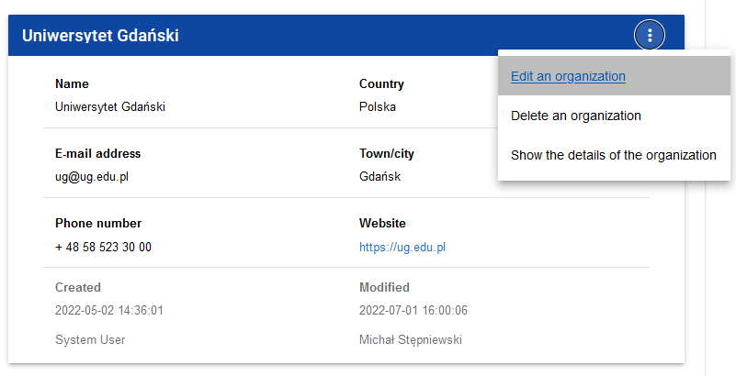

The organization edition screen will be displayed:

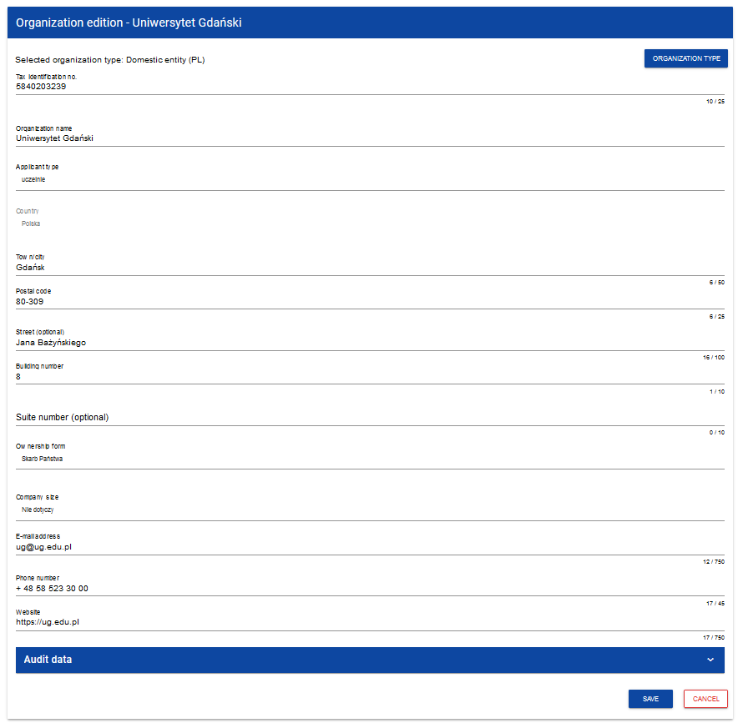

After you have finished updating respective fields and clicked ***Save***, the system will display a message acknowledging the completion of the operation.

# DELETING AN ORGANIZATION

If you want to delete one of your profiles connected with a specific organization, you should delete that organization. However, it is possible only when there is no application form created by you within the organization being deleted.

To this end, select ***Organizations list*** in the app menu on the left of the screen and then select ***Delete an organization*** in the list of organizations displayed.

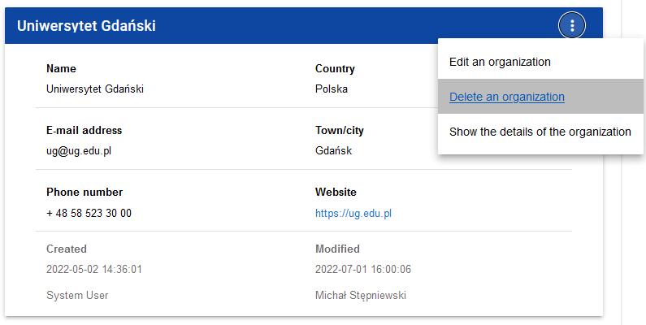

The following warning will be displayed:

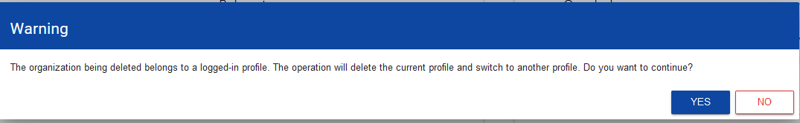

When you confirm, the organization will be deleted together with the profile associated with it.

**Note!**

* **If you delete the organization whose profile you are using at the moment, the system will change your current profile to another profile associated with another organization to which you belong.**
* **If you delete the only organization you have, the system will redirect you to the organization creation screen as during the user account registration process (see 1.1).**

# LOGGING IN

If you have already registered and have an account, you can log in to the system.

You can do this by clicking **I already have an account and want to log in** on the welcome screen or **Log in** in the user menu in the top right corner of the screen.

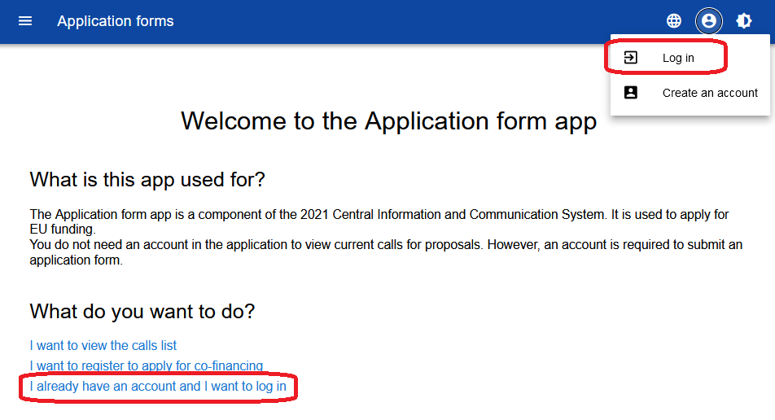

The app will display the log in window:

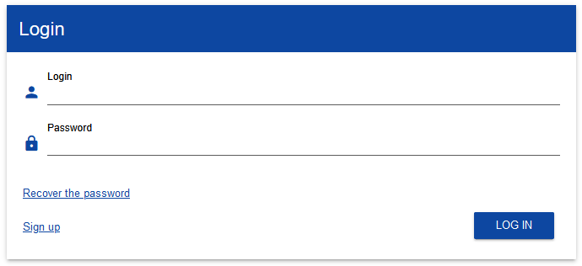

Give your login and password, and next select ***Log in***.

If you are the first user who has registered the organization, you are the Administrator and can view calls, create applications form and, in particular, create roles and profiles for other users within your organization (Chapter IV).

If you are a successive user of that organization, the Administrator must activate a profile in the system for you. Until that happens, on logging in, you will be able to see:

* the organization type selection screen (if your profile has not been created yet),
* a message informing you that your profile has not been activated yet.

After the Administrator has activated your profile, you will be able to start working in the system in line with the scope of the assigned rights.

# SELECTING THE LANGUAGE VERSION

After you have logged in to the system, you can change the language version. You already set the default language version of the app when you registered your account.

To change the language version, select the icon in the top right corner of the screen. You can choose from the following language versions:

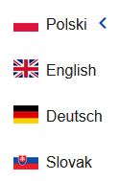

# ERGONOMICS AND ACCESSIBILITY

The WOD2021 app meets the requirements of the Act on the digital accessibility for websites and mobile apps of public sector bodies.

This means, in particular, that the System is responsive, i.e. the appearance and layout of the pages adjusts automatically to the size of the device's window. The pages are universal and displayed correctly on both large and small screens. The solution works correctly on both desktop and mobile devices.

# CHANGING THE CONTRAST

To change the screen contrast, select **High contrast** in the top right corner of the screen. You can choose from the following options:

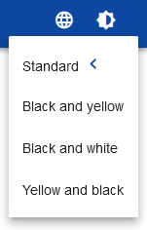

Selecting one will cause a corresponding change of the screen contrast. For example, if you select the black and yellow option, the screen will change as shown below:

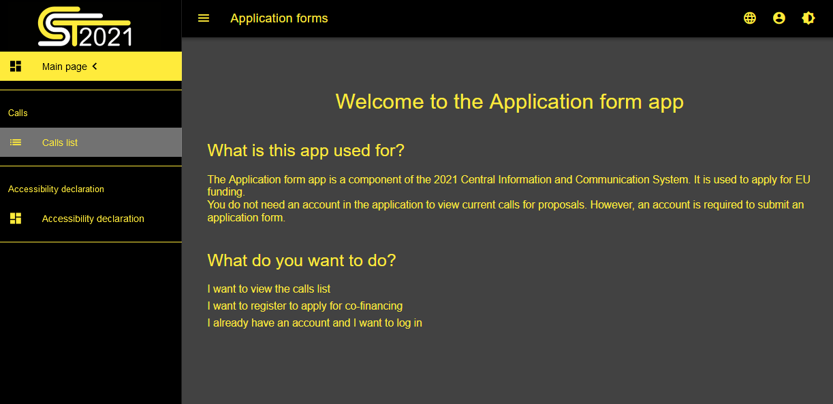

# EXTENDING A SESSION

After you log in, a session will start which will allow you to use the System for 30 minutes. The time remaining until the session end is displayed in the top right corner of the app:



A minute before your session expires, the System will show the following message:

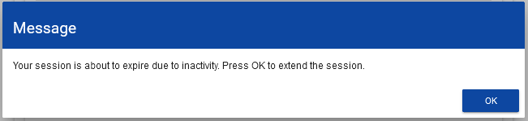

By clicking **OK,** you will extend the session by another 30 minutes. If you do nothing, your session will expire and you will be logged out.

To extend your active session before the expiry message is displayed on the screen, click the clock icon in the top right corner of the app or any element in the menu on the left panel of the app.

# FILTERING AND SORTING PANEL

The filtering and sorting panel allows selecting and changing the order of displayed elements. The panel is available for every list of elements in the System visible in the menu on the left of the screen, i.e. for calls and application forms created by the user, among other things.

By default, the ***Filtering and sorting panel*** is collapsed. To display its elements, click the panel expand arrow on the right of the bar.

When expanded, the ***Filtering and sorting panel*** looks as follows:

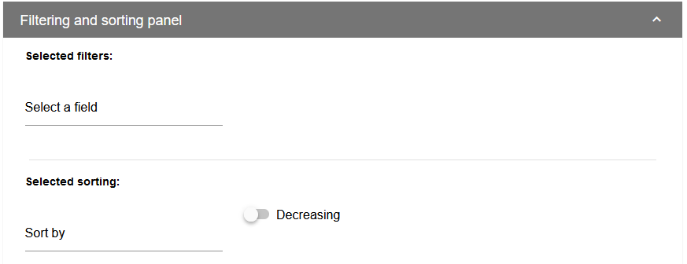

The panel is divided into two sections: ***Filtering*** and ***Sorting***.

To enter the first filtering condition, click **Select a field**. The system will expand a list of filters. The scope of the list will differ depending on which element of the menu on the left of the screen is to be subject to filtering.

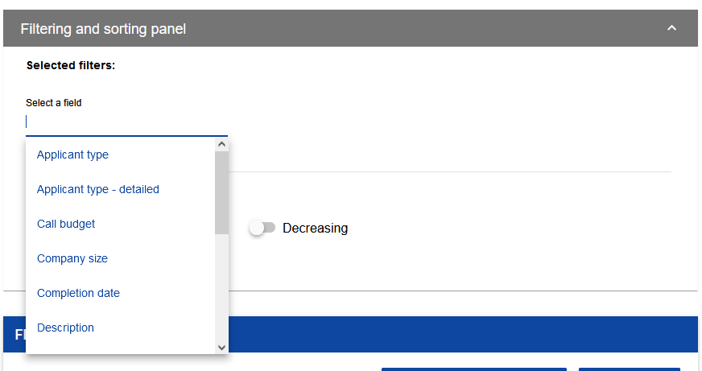

When a field is selected, the System will display the other fields required to create a filtering condition: ***Condition*** and ***Value***.

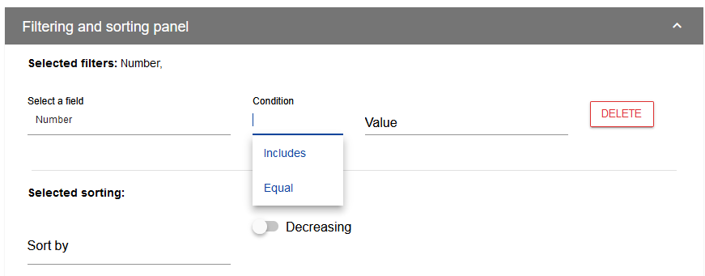

The ***Condition*** field can take to values: ***Equal, Includes***.

The ***Value*** field specifies what value the selected field will be compared with.

To delete a condition you have entered, click **Delete**.

When all the fields are filled in, the following three buttons will be displayed below the filtering conditions:



**Search** will start the filtering.

**Add a filter** will allow adding another condition.

**Clear the filters** will delete all the conditions entered.

To sort the elements in the list, click ***Sort by*** and from the drop-down list select the field by which you want to sort the elements. When a value is selected, the System will immediately sort the list.

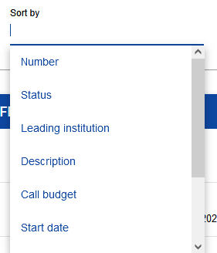

By using the toggle button, you can determine whether you want the elements to be displayed in the increasing or decreasing order.

Only one sorting condition can be active at any one time. When sorting is active, the field name will displayed as ***Selected sorting***. The System will also display the **Clear the sorting** button.

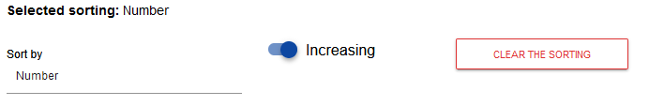

To restore the default sorting, select **Clear the sorting**.

# MANAGING USERS AND THEIR RIGHTS

**Note!**

* **This menu element is visible and available only for the user with the Administrator profile.**

In WOD2021, Applicants can independently manage the user rights within their organizations. The key role in defining user rights is played by *roles* and *profiles*:

- **Role** is a set of rights to perform specific operations in the System. The System offers default roles, available to every Applicant, and roles created by Applicants themselves.

- **Profile** is a set of roles held by a user as a member of a given organization (an employee of a given Applicant).

**Users are identified in the System by their respective e-mail addresses**.Every user can hold rights within several organizations (e.g. represent multiple Applicants), i.e. access profiles within each organization (Applicant) represented.

User operations and operations on granting the rights can be performed only by a user whose profile allows them to grant rights within their organization – the Administrator.

Roles created by the Administrator are automatically assigned to the organization to which the Administrator belongs.

# 4.1 MANAGING THE ROLES

Administrators, i.e. the users authorised to grant rights within their organizations, can view, create, edit and delete roles created for that organization (other than default ones).

# Viewing the roles

To view the existing roles assigned to the organization in the System, select ***Roles list*** in the main menu of the app.

The list includes both default roles, which cannot be deleted, and ones created by the Administrator for a given entity. Each role is presented in a separate card. Each card contains key information about the role, i.e. ***Name*** (top of the card bar),***Description,*** ***Rights sets***, ***Access right to elements*** and information whether **the role is a default one**. A description of visible attributes can be found in Section IV.4.1.1.1.

The other displayed elements are:

* ***Number of results,*** visible on the main bar of the view, gives information about the number of elements found.
* ***Number of results per page*** determines how many elements will be displayed per page and can be limited to 20, 40, 60, 80 or 100.
* ***Search by role name*** is used for quick searching the role whose name (visible on the top bar of the call card) and contains the caption entered. To search by name, enter the desired value and acknowledge by clicking **Enter**.

The **Create a role** button allows creating a role for an organization. A description of how to create a role can be found in Section IV.1.2.

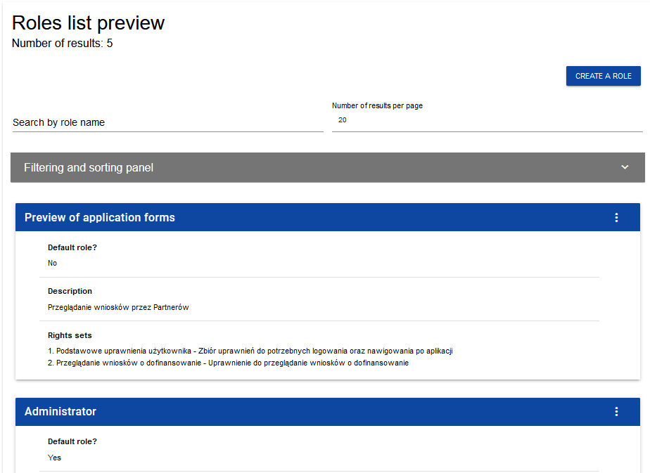

# Viewing the details of a role

To display details of a selected role click in the top right corner and select a desired element.

**Role details**:

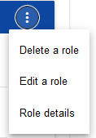

The System will display the role details screen:

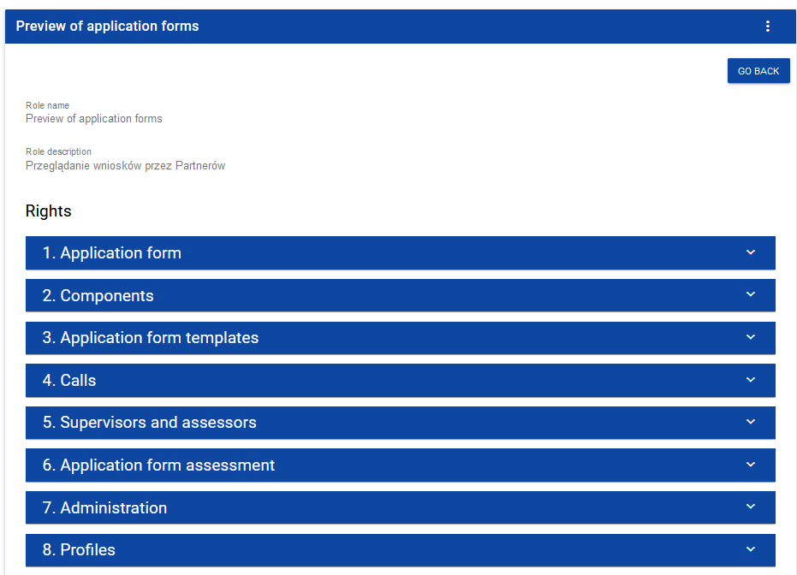

Clicking the bar of the selected right will expand applicable specific detailed rights (including the authorisation to grant rights).

# Creating a role

To create a new role, click **Create a role** in the top right corner of the role viewing screen or select **Role creation** from the main menu. The System will display the following screen:

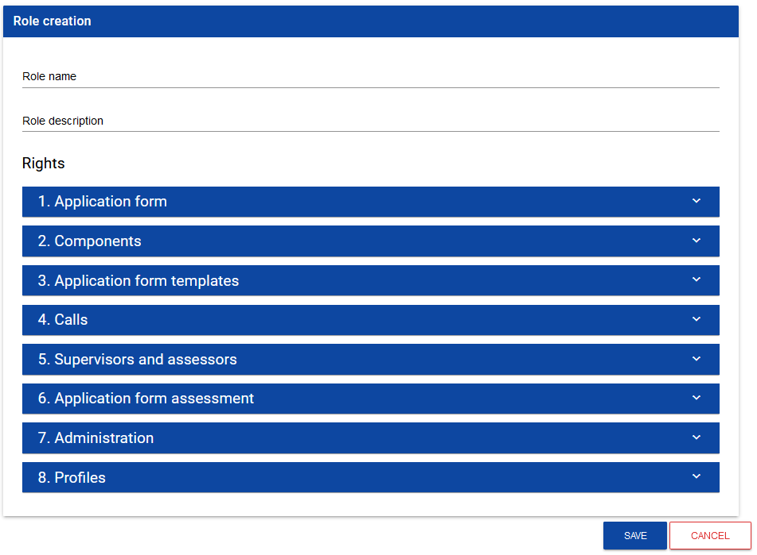

Clicking the bar with individual general rights bar will display a list of specific rights and access privileges regarding respective sections:

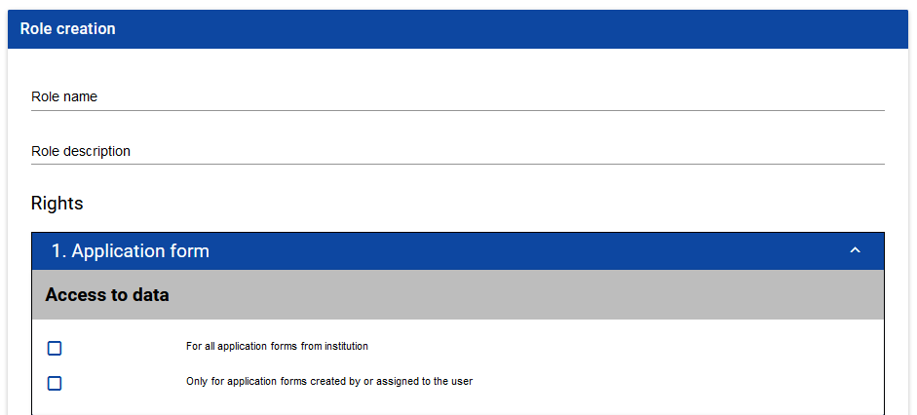

To create a role you must fill in the fields Name and Description, and tick the rights which the role concerned includes.

After entering all values for the newly created role, click **Save** to create the new role or **Cancel** to quit saving it. A warning message will be displayed during the saving process if any validation errors are encountered.

The newly created role will be automatically attached to the organization of the Administrator who has created it, and can be used for creating a profile containing the rights of successive users.

* **You can also create a role for partners participating in the projects. You can decide what scope of access they have and what kind of actions in the system they can proceed.**

# Editing a role

To edit a role selected from the roles list, click the icon in the top right corner of the bar and select **Edit a role**.



The System will display the screen of the selected role. Individual rights can be edited in the same way as in the role creation process (Section IV.4.1.2).

**Note!**

* **Default roles can only be viewed, not edited, from the roles list level.**

After entering the desired changes, click **Save** to update the role being edited or **Cancel** to quit modifying the role.

# Deleting a role

To delete a role selected from the roles list, click the icon in the top right corner of the bar and select **Delete a role**. Default roles cannot be deleted.



If the role being deleted is not used in any user profile, the System will display the following warning:

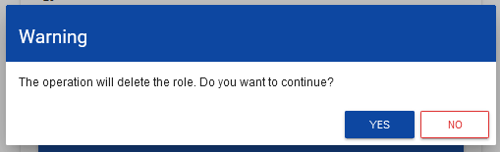

When the warning is acknowledged, the selected role will no longer be visible in the roles viewing screen.

If the role being deleted is used in any profile, an error message will be displayed instead of the warning.

# PROFILE MANAGEMENT

User profile operations can be performed only by a duly authorised Administrator. All profiles are automatically assigned to the organization within which that Administrator operates.

# Viewing the profiles

The existing profiles assigned to the Administrator's organization in the System can be viewed by selecting **Profiles list** in the main app menu***.*** The following view will be displayed:

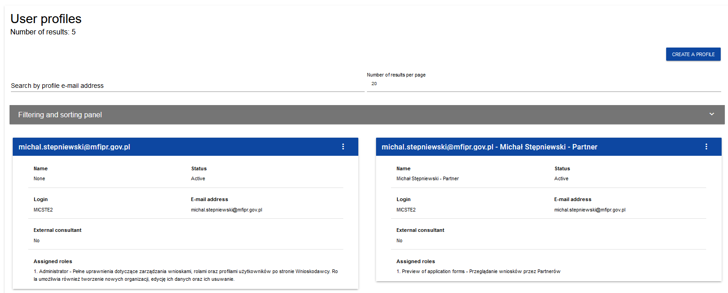

The view presents a list of profiles in the form of separate cards. Each card contains key information about a given profile, i.e.: ***Entity*** (the top bar of the card),***Name****,* ***Status****,* ***Login****,* ***E-mail address****,* ***External consultant****,* ***Assigned roles****.* A description of visible attributes can be found in Section IV.4.2.1.1.

The other displayed elements are:

* ***Number of results***, visible on the main bar of the view, gives information about the number of elements found.
* ***Number of results per page*** determines how many elements will be displayed per page and can be limited to 20, 40, 60, 80 or 100.
* ***Search by profile e-mail address*** is used for quick searching a profile by the e-mail address of the user to whom the profile is assigned. To perform the search, enter the desired value in the search field and click ***Enter***.

The **Create a profile** button allows creating a new profile.

# Viewing the details of a profile

To display the details of a selected profile, click the icon on the right of the bar and select **See the details**.

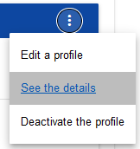

The System will display the role details screen:

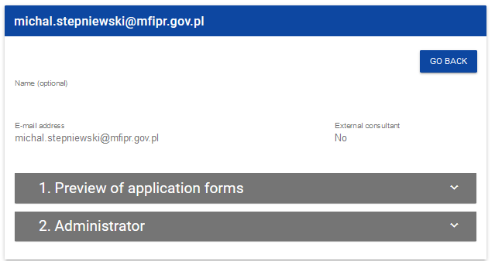

# Creating a profile

For a user (other than the Administrator) to be able to use the WOD2021 system, the Administrator must first create and activate a profile. The profile defines roles that include specific sets of rights to work in the system.

A new profile is created by clicking **Create a profile** in the top right corner of the profiles viewing screen or by selecting **Create a profile** in the main menu The System will display the following screen with a list of default roles available for the Administrator to assign within the profile being created:

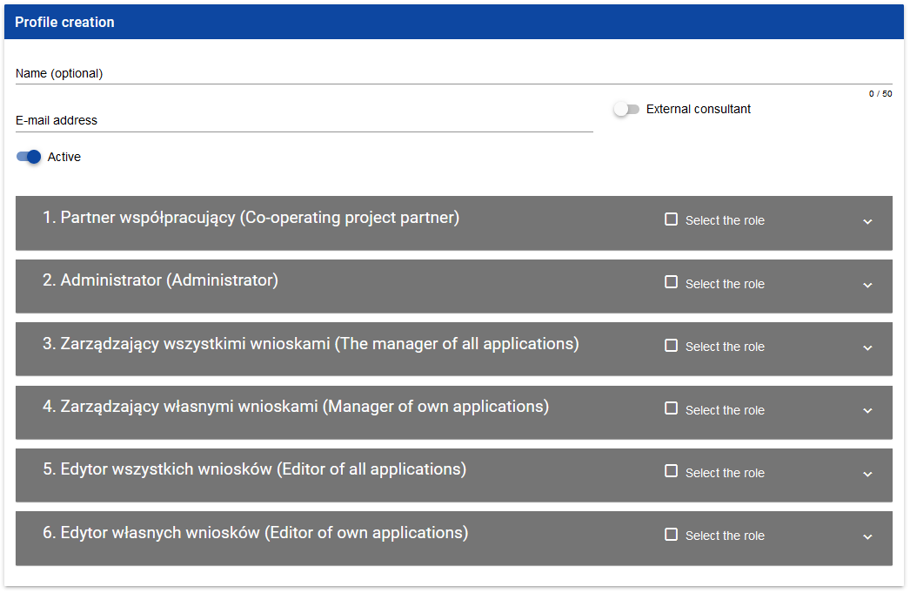

If the Administrator has created additional roles, these will be available in the profile creation screen:

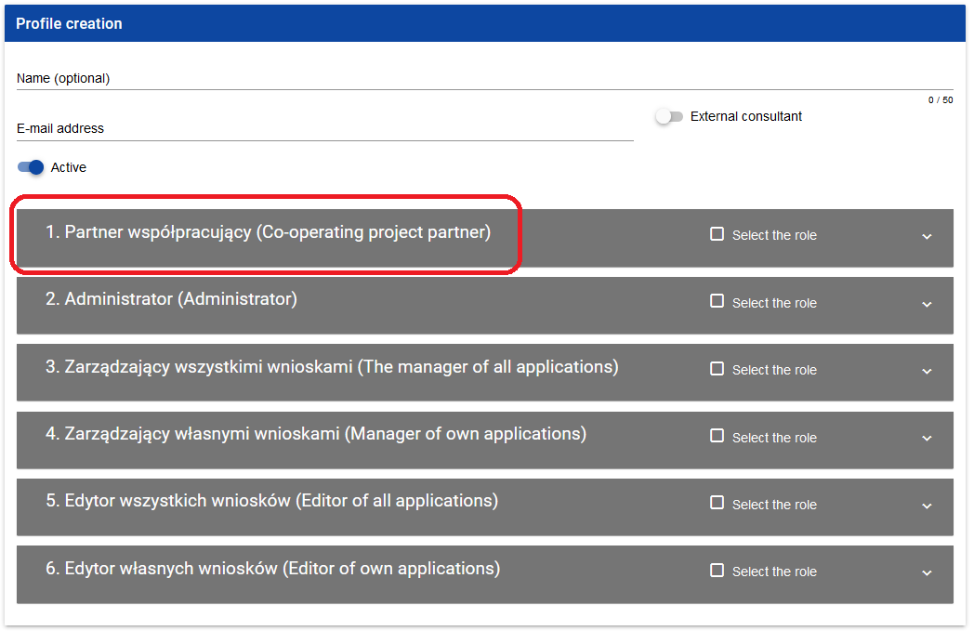

**Note!**

* **Roles which appear in the new profile creation screen are ones that have been defined for the organization to which the Administrator involved belongs.**
* **To create a new profile for a user, the latter must first register in the system in accordance with the guidelines provided in Section 1.1. If that condition is not met, the System will display an error message with information that the e-mail address entered has not been recognised.**
* **It is advisable to adopt a principle under which a profile name must include at least the first name and last name of the user for whom the profile concerned is being created. This will make it easier for the Administrator to manage the rights within his/her organization.**

After entering all values for the newly created profile, click **Save** to create a new role or **Cancel** to quit creating it. A warning message will be displayed during the saving process if any validation errors are encountered.

You can decide if a newly created profile will be given the status ***Active***.

# Editing a profile

To edit a profile selected from the profiles list, click the icon in the top right corner of the bar and select **Edit a profile**:

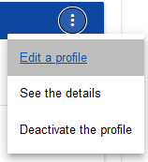

The System will display the selected profile:

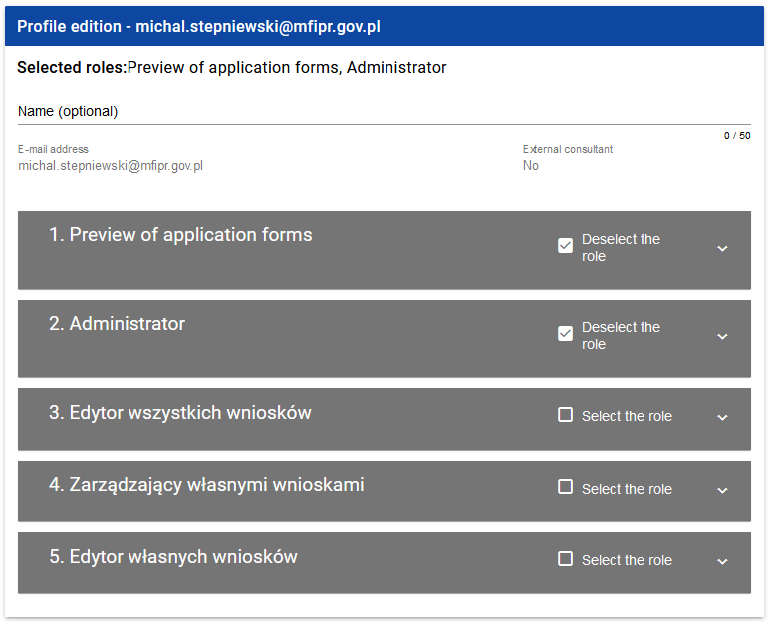

After entering the desired changes, click **Save** to update the profile being edited or **Cancel** to quit saving it.

# Activating a profile

Activation of a user profile enables the user to use the profile when working in the system. To this end, enter the profiles list, select a deactivated profile, click the icon in its top right corner and select

**Activate the profile**:

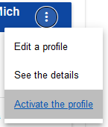

The System will display the following message asking the user to acknowledge the profile activation:

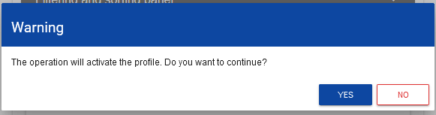

Acknowledging the operation will give the profile the ***Active*** status.

# Deactivating a profile

Deactivating a user profile will make the user unable to use it when working in the system. To this end, enter the profiles list, select an active profile, click the icon in the top right corner of the bar and select

**Deactivate the profile**:

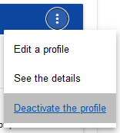

The System will display the following message asking the user to acknowledge the profile deactivation:

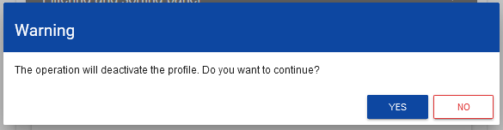

Acknowledging the operation will give the profile the ***Deactivated*** status.

# CALLS - viewing

The WOD2021 system displays a list of started calls under which an application form can be created.

# VIEWING THE CALLS LIST

The calls list is presented in the form of separate cards. You can sort and filter it by the content of individual fields.

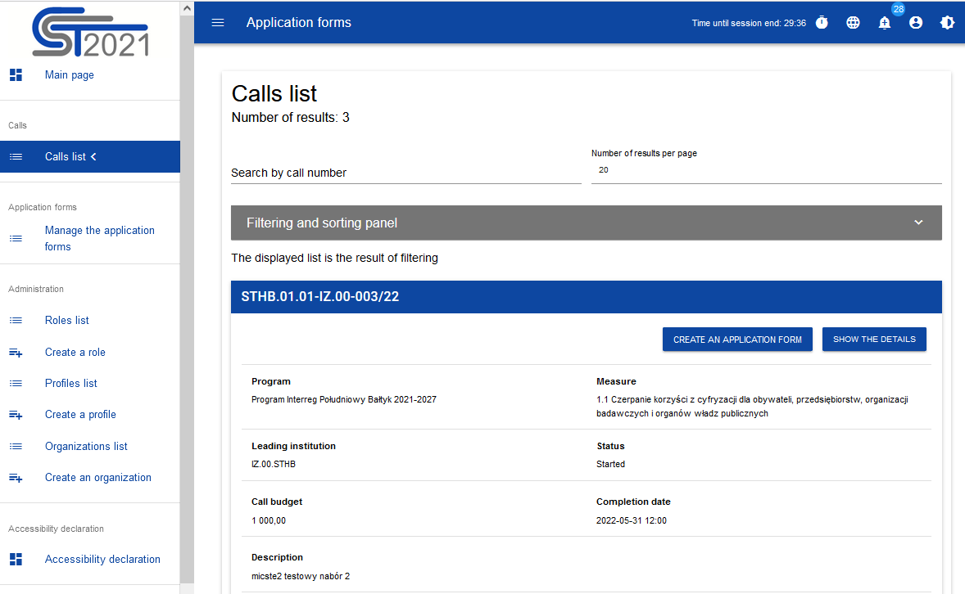

# Viewing the details of a call

If you want to view all information about a given call, click **Show the details** (below the blue bar with the call number).

# CALLS SEARCH

Calls are created separately for each specific objective/measure. In the calls list, to find a call announced within a given programme, enter at least the programme's code in the search field:

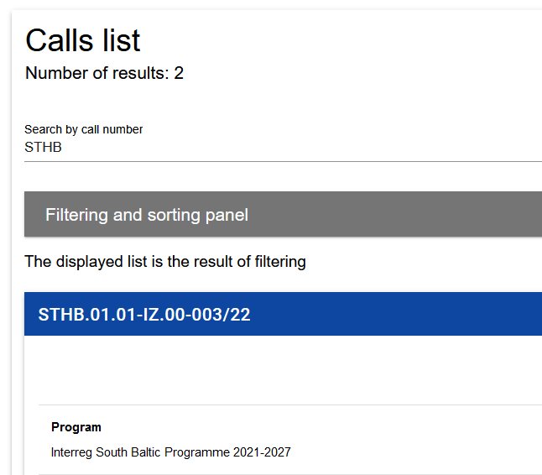

You can also add further characters from the call number, representing the number of the priority and specific objective, e.g. PLUA.01.01.

# APPLICATIONS FORMS

An application form is created by indicating the applicable call based on the attached application form template. It contains 12 sections:

1. Project information
2. Applicant and project partners
3. Project indicators
4. Work packages
5. Project budget
6. Budget summary
7. Co-financing sources
8. Risk analysis
9. Additional information
10. Statements
11. Appendices
12. Application form data

Editing a certain section sometimes requires completing element of one or more preceding sections, as certain data entered in opening section us used for defining the data in subsequent ones.

Sections VI and XII are non-editable because they are created automatically on the basis of the data either from the preceding sections or the call.

# 6.1. VIEWING THE APPLICATION FORMS

Viewing the application form differs slightly depending on the user.

If you are an **Applicant**, i.e. you have created one or more application forms in the system, then you can view only the applications you have created.

If you are not an Applicant, then you can view only the applications which have been made available to you by the Applicant. You are then the so-called **Collaborator** of the Applicant.

To display a list of application forms, click **Manage the application forms** in the main menu. The following screen will be displayed:

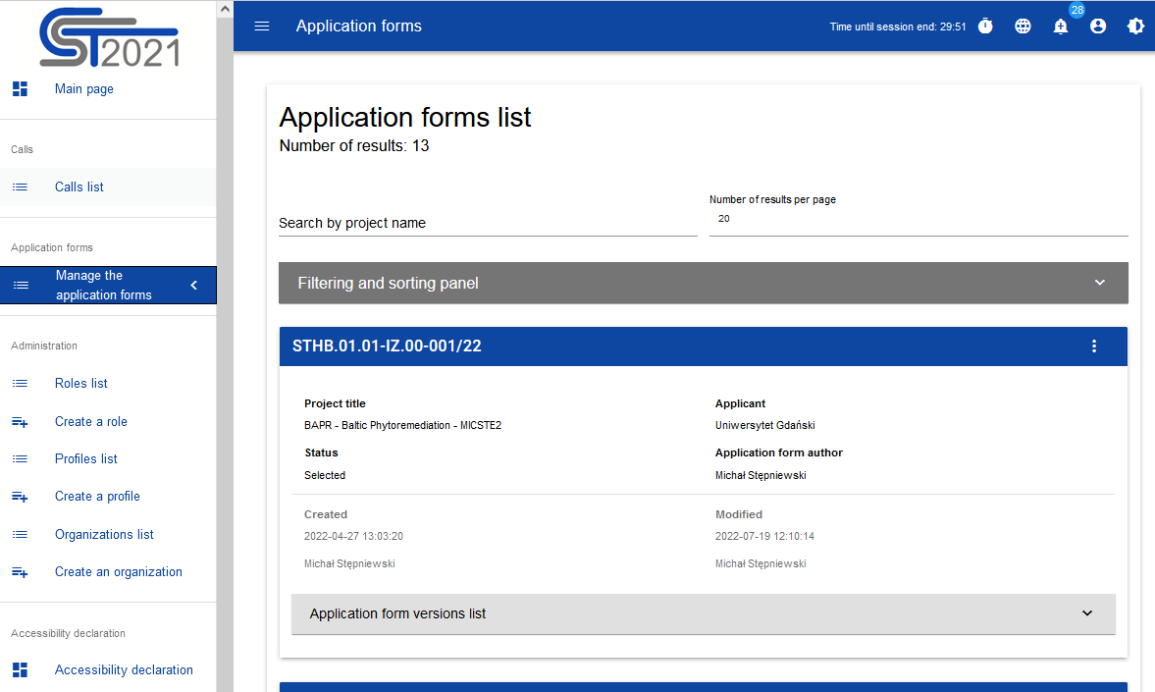

The view presents a list of application forms in the form of separate cards. Each card contains key information about the application, i.e. ***Call number***(the top bar of the card), ***Project title****,* ***Status****,* ***Application form author****.* A description of all attributes in the applications sections can be found in Section VI.6.1.1.

If the application displayed has official versions, it is indicated with a grey bar on at the bottom of the application box. Viewing the individual version is explained in Section VI.6.3.

The other displayed elements are:

* ***Number of results***, visible on the main bar of the view, gives information about the number of elements found.
* ***Number of results per page*** determines how many elements will be displayed per page and can be limited to 20, 40, 60, 80 or 100.
* ***Search by project name*** is used for quick searching an application whose title contains the phrase entered. To perform the search, enter the desired value in the search field and click **Enter**.
* ***Sorting and filtering panel*** is described in Chapter III.

# Viewing the details of application forms

The content of all sections and fields of the application form can be displayed by selecting the version preview option in the menu of the selected application:

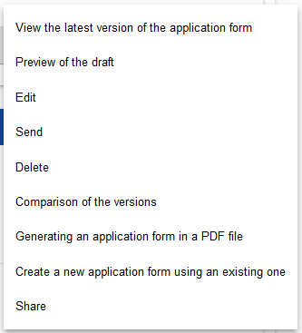

Draft versions can be viewed only in the case of applications with the status of "under preparation", "under clarification" and "under correction". For other statuses, only the official version of an application can be viewed (Section VI.6.3).

The System will display an application form preview screen set at Section I:

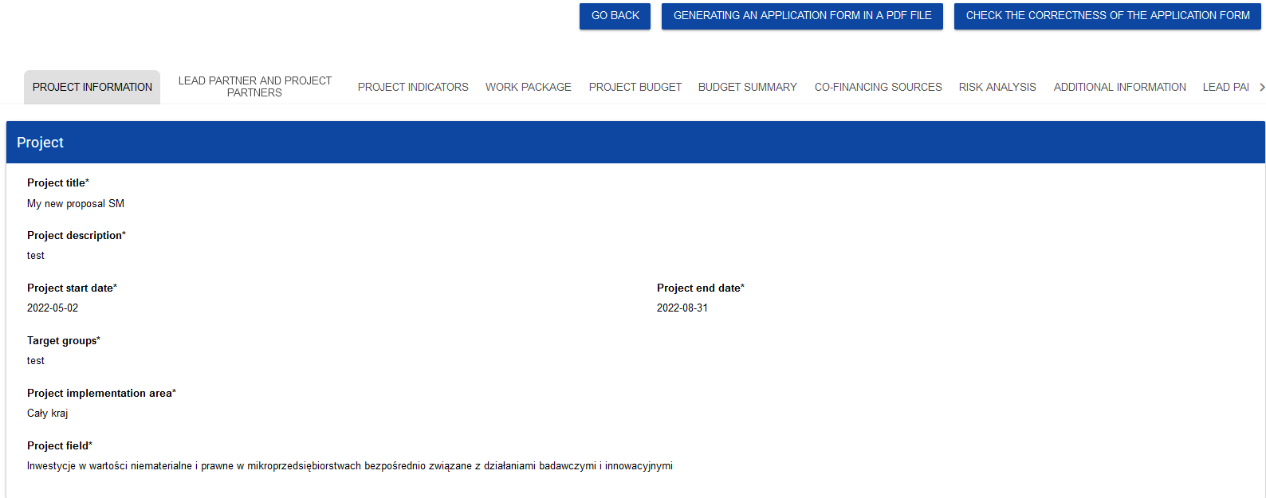

To view the content of specific sections of the selected application form, click the name of the desired section. Section names can be scrolled with the "**<**" and "**>**" buttons to the left and right of the section bar at the top of the screen. The name of the section selected to be viewed is shown on grey background.

To return to the application form list, click **Go back** in the top right corner of the screen.

# CHECKING THE CORRECTNESS OF THE APPLICATION FORM

Correctness checking is available only for draft application forms. When a preview of the draft version of the application form is displayed, click **Check the correctness of the application form** in the top right corner of the application form screen. If there are any errors, a panel with an errors list will be displayed:

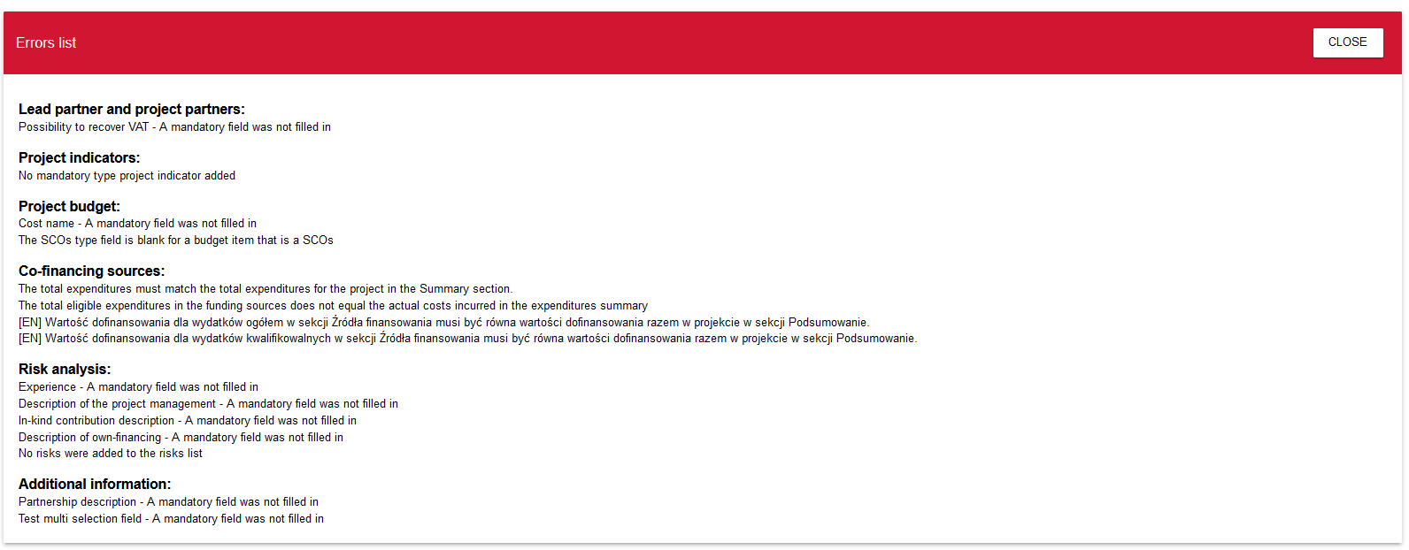

The application form correctness checking process can be started also during editing of the application form (but not its individual sections).

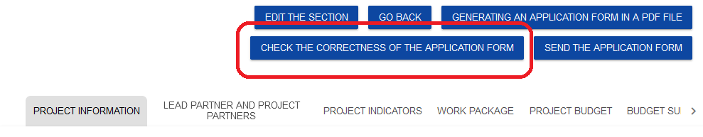

It is also run automatically when the application form is being sent to the Joint Secretariat.

# VIEWING APPLICATION FORM VERSIONS

An application form can have official versions and a draft version.

**Official versions** are created when an application form is being sent to the Joint Secretariat and after the Joint Secretariat has corrected the application form.

**A draft version** is created during the process of editing or improving by the applicant, correcting by the Joint Secretariat. The current version applies therefore to applications with the status ***Under preparation, Under clarification*** or ***Under correction.*** It can be previewed with the application form preview function.

**Official versions** of an application form are available from the level of the application form versions list. If an application has a status other than ***Under preparation***, click the button and the drop-down list ***Official versions of the application form*** will be displayed at the bottom of its card.

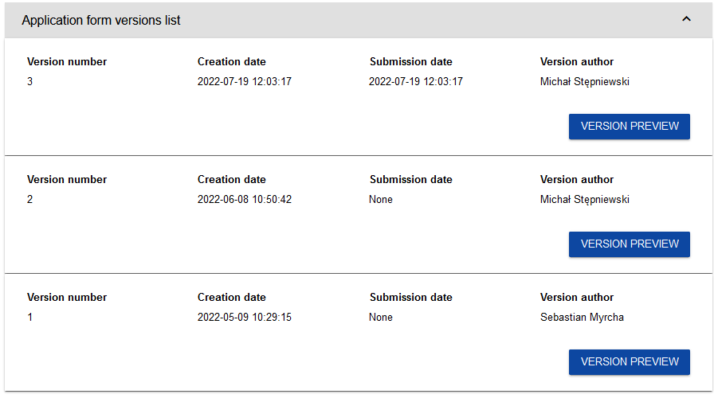

Official versions are sorted in the reverse chronological order: from the latest to the oldest.

To open the details of a selected version, click **Version preview**.

If any notes have been made in the version concerned, e.g. during the process of evaluation of the application form at the Joint Secretariat, you can display them by clicking the grey bar ***Information about the entered note*** at the top of the screen:

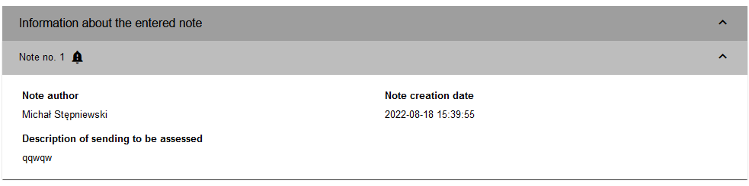

**Note!**

* **Some official versions can be marked as *Historic* because they were created not as a result of sending the application form to the authority or as a result correcting it, but as a result of changes to the application form after the start of the call concerned.**

# COMPARING THE VERSIONS

To compare one version of an application form with another version of the same application, select **Comparison of the versions**

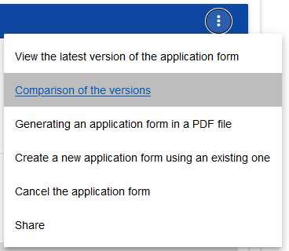

The System will display the version forms comparison screen. From the drop-down menu, select the base line version (***Select a version number*** on the left of the screen) and the compared version (***Select a version number*** on the right of the screen).

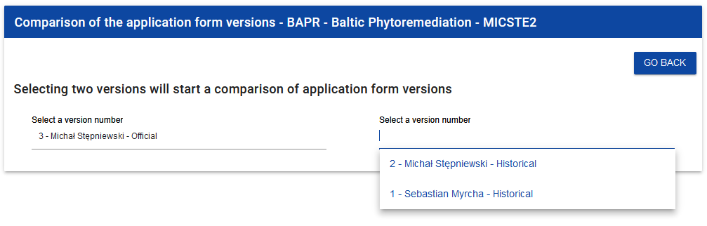

The system will display the result of the comparison:

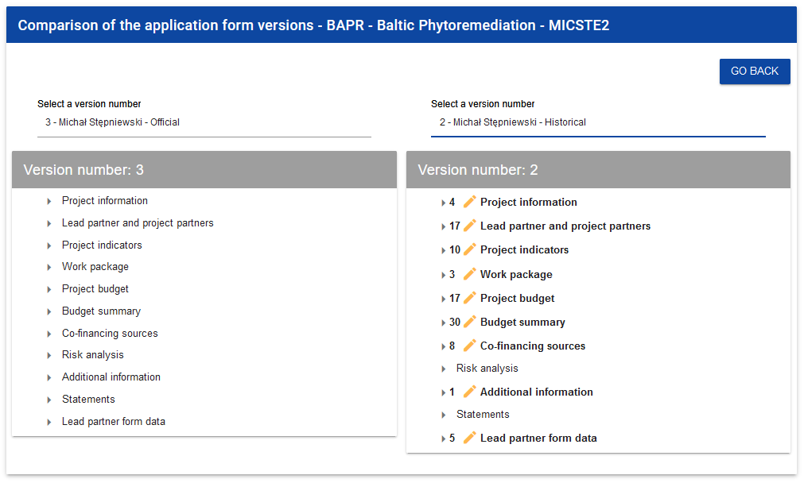

The content of each version is displayed hierarchically, i.e. all sections will be displayed at the first hierarchical level, with components contained in hierarchically higher sections/components displayed further on. The last hierarchical level includes only individual fields. You can collapse and expand individual levels for both displayed versions of the application form.

The comparison involves showing the differences between corresponding fields in the baseline and compared versions:

- if a component or field has been added, it will be marked in the compared version with the icon

- if a component or field has been deleted, it will be marked in the compared version with the icon

- if a component or field has been modified (e.g. its label and/or type has changed), then it will be marked in the compared version with the icon