###### WOD2021

###### Interreg Applicant Manual

**Application form**

31 March 2025

Version 1

List of contents

1. APPLICATIONS FORM – the Applicant's perspective 4

1.1. Creating an Application form 6

1.2. Editing an Application form 8

1.2.1. Section I *Project information* 11

1.2.2. Section II *Applicant and Project Partners* 15

1.2.3. Section III *Project indicators* 22

1.2.4. Section IV *Work packages* 26

1.2.5. Section V *Project budget* 29

1.2.5.1. Filling in the *Project budget* directly in the system 30

1.2.5.2. Filling in the *Project budget* in an .xlsx file template 37

1.2.6. Section VI *Budget summary* 40

1.2.7. Section VII *Co-financing sources* 42

1.2.8. Section VIII *Risk analysis* 46

1.2.9. Section IX *Additional information* 50

1.2.10. Section X *Statements* 54

1.2.11. Section XI *Appendices* 55

1.2.12. Section XII *Application form data* 57

1.3. Deleting an Application form 59

1.4. Sending an Application form for assessment 60

1.5. Clarifying an Application form 61

1.6. Cancelling an Application form 63

1.7. Creating an Application form on the basis of another Application form 64

2. SYSTEM MESSAGES 65

2.1. FIELD VALIDATION 65

2.2. BUSINESS RULES 66

2.3. WARNINGS 66

2.4. MESSAGES TO APPLICANTS 67

# APPLICATIONS FORM – the Applicant's perspective

To create an Application form, you must first register and log in to the system, and then search the calls under which you intend to submit an Application form. To this end, follow the instructions laid out in the PL-UA 21-27 WOD2021 Applicant Manual – General Part.

**Note!**

* **Terminology used in the system slightly differs from that used in the Programme (and the Programme Manual). The term *Applicant* shall mean an entity/institution which takes the role of the *Lead Partner* in a given project. Project Partners shall mean other partners in the project.**

The applicant creates an application form referring to the relevant call. The application form includes 12 sections:

1. Project information
2. Applicant and project partners
3. Project indicators
4. Work packages
5. Project budget
6. Budget summary
7. Co-financing sources
8. Risk analysis
9. Additional information
10. Statements
11. Appendices
12. Application form data

Editing a certain section sometimes requires completing the element of one or more preceding sections, as certain data entered in opening section is used for defining the data in subsequent ones.

Sections VI and XII are non-editable because they are created automatically on the basis of the data either from the preceding sections or the call.

In your application, you, as an ***Applicant*** (and the ***Collaborators*** authorised by you), can describe the project for the co-financing of which you are applying.

Next, you send a correctly completed Application form to the Joint Secretariat **only via WOD2021 Application System**.

**It is strongly recommended to create the account shortly after the call announcement in order to get familiar with the system structure and functionalities. Please note that the first person that registers from an organization in WOD2021 becomes automatically the Administrator of the organization in the system. Only users with Administrator role can grant access to newly registered users from the same organization. Therefore, it is crucial to be aware who is the Administrator in an organization and contact them after registering as not a first user. It is highly recommended to designate more than one Administrator once more users from the same organization have registered in the system.**

**Note!**

* **All applicants and logged-in users should work only on English version of the WOD2021 system to avoid any potential errors.**

The Joint Secretariat reserves the right to request any partner to submit additional documents during the assessment process (before approval of the project) to support the assessment of their financial, organizational and/or management capabilities and eligibility in accordance with the Programme rules.

It is crucial to complete the Application form and its attachments accurately and provide all documents in the required format. Furthermore, it is highly recommended to get familiar with the assessment criteria in order to meet the Programme requirements (ref: Programme Manual, chapter 7 and Annex 2.1. Application form assessment grid).

In case of any questions or problems concerning the process of filling in the Application form or its attachments and general issues related to your application, please do not hesitate to contact the Joint Secretariat (JS) via e-mail [js@pl-ua.eu](mailto:js@pl-ua.eu).

# Creating an Application form

Each Specific objective (SO) has its own call announcement with a unique number in WOD2021.

To see the announcements for the Programme in the field **‘Search by call number**’ please type ‘**PLUA**’ (the Programme code in WOD2021).

**1st CALL FOR PROPOSALS – CALLS IN WOD2021**

**Priority ENVIRONMENT**

SO 1.1. Promoting climate change adaptation and disaster risk prevention and resilience, taking into account ecosystem-based approaches – **PLUA.01.01-IP.01-001/23**

SO 1.2. Promoting access to water and sustainable water management – **PLUA.01.02-IP.01-001/23**

SO 1.3. Enhancing protection and preservation of nature, biodiversity and green infrastructure, including in urban areas, and reducing all forms of pollution – **PLUA.01.03-IP.01-001/23**

**Priority HEALTH**

SO 2.1. Ensuring equal access to health care and fostering resilience of health systems, including primary care and promoting the transition from institutional to family-based and community-based care – **PLUA.02.01-IP.01-001/23**

To create a new application form, open the ***Calls list***, find the open call under which you want to apply for co-financing, and next select  in the selected call. The button is also in the details screen of the selected call.

The following screen will be displayed:

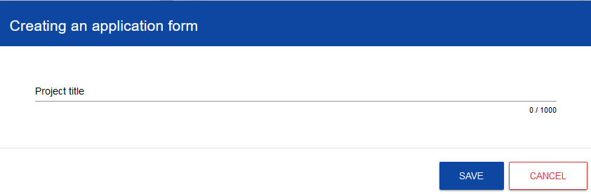

First, enter your project title. When you enter the project title and confirm it by clicking ***Save***, a new application form is created. It will be visible on your list of application forms.

**Note!**

* **Where during the registration in the system your organization indicated a different *Type of applicant* or *Size of enterprise* than in the call for which you are creating your application form, the following warning will be displayed:**

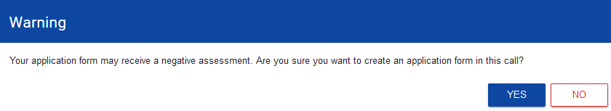

Contact the Joint Secretariat to clarify these discrepancies.

# Editing an Application form

If you want to edit your Application form, go to the list of application forms by clicking ***Manage application forms*** in the main menu, and next select ***Edit*** in the menu of the selected application form:

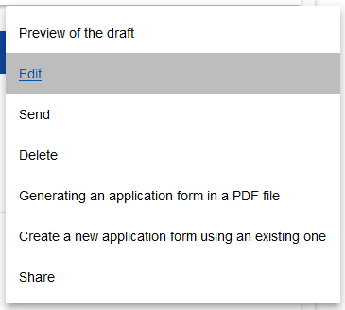

You will be redirected to the screen with Section I of the Application form.

**Note!**

* **If you start editing your application form when the template of the application form has changed, the proper warning will be displayed.**

This means that certain field may disappear from the form or some new field and/or values may be added. To protect the fields and values saved in the application form before the template change, a historic version is created which a user can access from the list of application forms.

Displayed above the current section is a bar with the names of individual project sections. If you want to change a project section, select the desired tab. Section tabs (if extend beyond the page view on the screen) can be scrolled with the "**<**" and "**>**" buttons on the left and right of the section bar at the top of the screen. The currently selected section is displayed with a grey background.

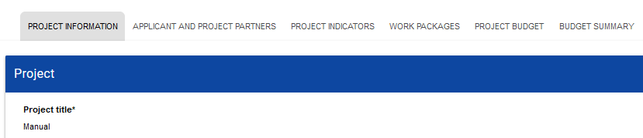

To start editing, select ***Edit the section*** in the top right corner of the screen. Only then the relevant fields and/or tables of the section become editable.

**Note!**

* **Editing is performed separately for each section. You cannot edit multiple sections simultaneously. However, you can view other project sections when editing the selected section and no data will be lost.**

The System allows multiple users to work on an application form simultaneously. However, if one user is editing a section of an Application form, no other user can edit that section at the same time.

Other users, i.e. except for the one who is editing a given section at the moment, see the section with the icon on the right of the tab name. The user editing the section sees the icon . An attempt to edit a blocked section will evoke an error message.

To save the data you have entered and/or updated, click ***Save***. To finish editing a section, select ***Finish editing*** in the top right corner of the section screen. The following warning will be displayed:

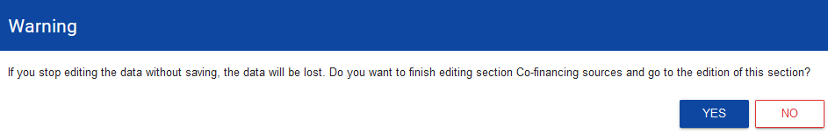

You can also finish editing a section by proceeding directly to editing another section. To do so, go to another section and select ***Edit the section*** in the top right corner of the screen. In this case, a warning will also appear.

Clicking ***Go back*** when editing a section will evoke the following warning:

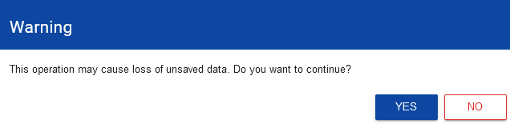

When you confirm, the editing will be stopped and you will return to the list of application forms.

# Section I *Project information*

When you proceed to Section I, the following screen will be displayed:

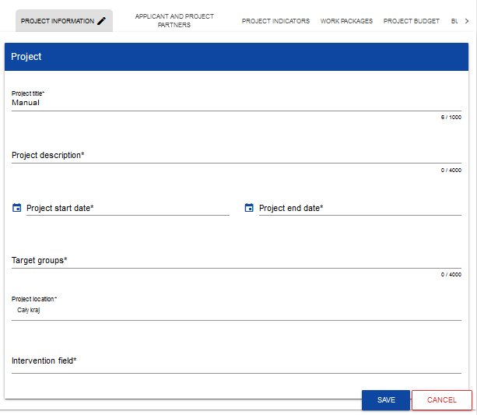

Below you can find descriptions of the fields which must be filled in when creating Section I of a new application form. The required fields are marked with an asterisk:

|  |  |  |
| --- | --- | --- |
| **Field name** | **Field type** | **Manner of completion** |
| Project title*  (*max 200 characters*) | text | Please provide the Project title. It should be short, easy to understand and it should clearly describe the nature of the project  The title should identify the project while not duplicating the titles of other projects implemented by the Lead Partner or other entities. |
| Project description*  (*max 200 characters*) | text | Please give a short overview of the project and describe:  - the common challenge of the Programme area you are jointly tackling in your project;  - the overall objective of the project and the expected change your project will make to the current situation;  - the main outputs you will produce and who will benefit from them;  - the approach you plan to take and why is cross-border approach needed. |
| Project start date* | date | Select the year, month and day of the project start from the calendar.  The earliest start date of the project can be the day after the end date of the respective Call for proposals. |
| Project end date* | date | Select the year, month and day of the project end from the calendar. It must be later than the project start date. The project end date should cover also the financial completion of the project.  The regular project duration is up to 24 months. |
| Target groups*  (*max 4000 characters*) | text | A description of the groups to whom the project is addressed. In this field, describe who will be supported under the project and identify – based on generally available data and, possibly, the Partners’ own data – important characteristics of the participants (individuals or entities) who will receive support, including the project implementation area.  The Lead Partner and other Project Partners should describe the target group in a manner that allows the person assessing the project to clearly determine whether the project is addressed to a group that is eligible to receive support in accordance with the provisions of the call's Programme basis and detailed project selection criteria. |
| Project location* | list of values | It defines in which specific region the project is implemented  Please select the value "region". The system will then ask you to fill in the **Project location** table. |
| Intervention field* | list of values | This field specifies the field of activity which the project concerns. Select one value from the list.  Please note that the list is determined for each Specific objective. The fields of intervention (related types of action for each Specific objective) are specified in the [Programme document](https://pbu2020.eu/files/uploads/pages_en/pbu2021-2027/JOP%20zatwierdzony/Interreg%20NEXT%20PL-UA%20JOP%20approved%2030.11.2022.pdf). |
| **Project location\*** | **list of objects** | Identification of the place (or places) of implementation of the project at the voivodeship/oblast, district and municipality/commune level. If the project is implemented across an area covering more than one district or municipality/commune, list them by adding them from the list.  Individual locations are added by clicking the "+" icon on the list title and deleted by clicking the "x" icon on the title of the location concerned.  Please list all the places where your project is planned to be implemented (i.e. all locations of your project partners). |
| * Region/Voivodeship* | list of values | Voivodeship/Oblast of implementation. Selected from the dictionary. |
| * District* | list of values | District/Area of implementation. The choice in the dictionary is narrowed down to the previously selected voivodeship/oblast.  Please note that in case of Mazowieckie voivodeship the Programme does not cover all the districts (see the Programme Manual – Programme Area, p. 1.2). |
| * Municipality/Commune | list of values | Municipality/commune of implementation. The choice in the dictionary is narrowed down to the previously selected district. This field is filled in only for areas in Poland. |

**Note!**

* **The *Project location* table is filled in only when the value of the *Project location* (above) is *Region*. The System will display the following table to be filled in:**

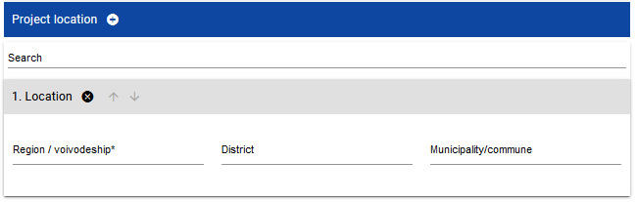

# Section II *Applicant and Project Partners*

When you select Section II for editing, the following screen will be displayed:

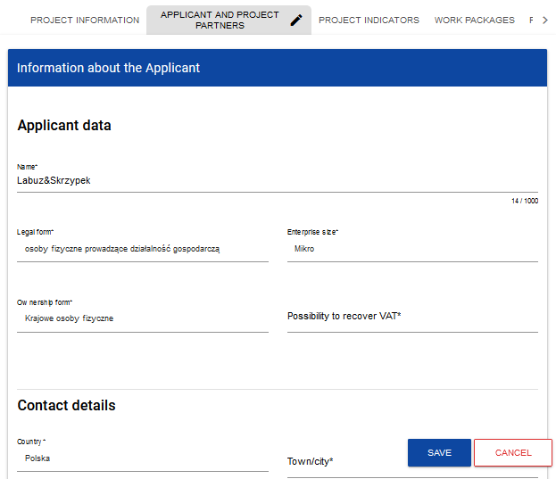

The applicant is the entity/institution which takes the role of the Lead Partner in the project. Project Partners are other partners in the project.

The applicant's data are already partially given on the basis of information provided during registration in the system. The data are editable.

Below you can find descriptions of the fields which must be filled in when creating Section I of a new application form. The required fields are marked with an asterisk:

|  |  |  |
| --- | --- | --- |
| **Applicant's data** | | |
| **Field name** | **Field type** | **Manner of completion** |
| Name*  (*max 1000 characters*) | text | Specify the full name of the Lead Partner in English as provided in the registration documents/statutes of the entity.  If the official English name of the Lead Partner does not exist, please provide the English translation that the Lead Partner will use in the future for all applications created in WOD2021. |
| Legal form* | list of values | Select the value that best corresponds to the legal form of the Lead Partner. You can choose from several dozen types. |
| Ownership form* | list of values | Select the value that corresponds to the form of ownership according to the legal form of the Lead Partner:   * for Polish partners: the value that best corresponds to the form of ownership according to the legal form of the Lead Partner, but other than ‘Foreign entities’, * for Ukrainian partners: ‘Foreign entities’. |
| Enterprise size* | list of values | Please select "Not applicable". To act as a Lead Partner in the Programme an organisation must be established under public law and fall under one of eligible legal form specified in the Programme Manual (p. 4.6). |
| Possibility to recover VAT* | list of values | Indicate whether you, as the Lead Partner, have the possibility to recover VAT. Where this is irrelevant to the project, you can also select "Not applicable". |
| **Contact details** | | |
| **Field name** | **Field type** | **Manner of completion** |
| Country* | list of values | Specify the country of the Lead Partner. |
| Town/City* | text | Enter the town/city of the Lead Partner:  - For Polish Lead Partner: select from the drop-down list,  - For Ukrainian Lead Partner: enter the name of the town/city. |
| Postcode* | text | Specify the postcode of the Lead Partner's registered office. |
| Street* | text | Select the street address of the Lead Partner's registered office:  - For Polish Lead Partner: select from the drop-down list,  - For Ukrainian Lead Partner: enter the street address of the Lead Partner's registered office. |
| Building number* | text | Specify the building number of the Lead Partner's registered office. |
| Apartment/office number | text | Enter the flat number of the Lead Partner's registered office. |
| E-mail address* | text | Specify the official e-mail address of the Lead Partner. |
| Phone number | text | Specify the phone number of the Lead Partner. |
| Website | text | Specify the address of the Lead Partner's website. |
| **Identification details** | | |
| **Field name** | **Field type** | **Manner of completion** |
| Identifier type* | list of values | Please select from the drop-down list:   * For Polish Lead Partner: ‘Tax identification no.’ (NIP), * For Ukrainian Lead Partner: ‘Other number’. |
| NIP/PESEL/Other* | text | Enter your ID number in accordance with your selection in the previous field.   * For Ukrainian Lead Partner: Код ЄДРПОУ |

The ***Project Partners*** table must be filled in because projects in the Programme are implemented ONLY in the form of partnerships. The term Project Partner shall mean a partner in the project.

The ***Project Partners*** table has the same fields as those in the ***Information about the Applicant***:

|  |  |  |
| --- | --- | --- |
| **Project Partners** | | |
| **Field name** | **Field type** | **Manner of completion** |
| Whether the Applicant expects other entities to participate in the implementation of the project | logical variable | Tick to add information about partners in the implementation of the project. When the field is ticked, the system will add a section in which partner data can be provided.  You can add further partners by clicking .  You can delete partners with . |
| **Project Partner data** | | |
| **Field name** | **Field type** | **Manner of completion** |
| Name*  (*max 1000 characters*) | text | Specify the full name of the Project Partner as provided in the registration documents/statutes of the entity. |
| Legal form* | list of values | Select the value that best corresponds to the legal form of the Project Partner. You can choose from several dozen types. |
| Ownership form* | list of values | Select the value that corresponds to the form of ownership according to the legal form of the Project Partner:   * for Polish partners: the value that best corresponds to the form of ownership according to the legal form of the Project Partner, but other than ‘Foreign entities’, * for Ukrainian partners: ‘Foreign entities’. |
| Enterprise size* | list of values | Please select "Not applicable". To act as a Project Partner in the Programme an organisation must be established under public law and fall under one of eligible legal form specified in the Programme Manual (p. 4.6). |
| Possibility to recover VAT* | list of values | Indicate whether you, as the Project Partner, have the possibility to recover VAT. Where this is irrelevant to the project, you can also select "Not applicable". |
| **Contact details** | | |
| **Field name** | **Field type** | **Manner of completion** |
| Country* | list of values | Specify the country of the Project Partner. |
| Town/City* | text | Enter the town/city of the Project Partner:  - For Polish Project Partner: select from the drop-down list,  - For Ukrainian Project Partner: enter the name of the town/city. |
| Postcode* | text | Specify the postcode of the Project Partner's registered office. |
| Street address* | text | Select the street address of the Project Partner's registered office:  - For Polish Project Partner: select from the drop-down list,  - For Ukrainian Project Partner: enter the street address of the Project Partner's registered office. |
| Building number* | text | Specify the building number of the Project Partner's registered office. |
| Apartment/office number | text | Enter the flat number of the Project Partner's registered office. |
| E-mail address* | text | Specify the official e-mail address of the Project Partner. |
| Phone number | text | Specify the phone number of the Project Partner. |
| Website | text | Specify the address of the Project Partner's website. |
| **Identification details** | | |
| **Field name** | **Field type** | **Manner of completion** |
| Identifier type* | list of values | Please select from the drop-down list:   * For Polish Project Partner: ‘Tax identification no.’ (NIP), * For Ukrainian Project Partner: ‘Other number’. |
| NIP/PESEL/Other* | text | Enter your ID number in accordance with your selection in the previous field.  For Ukrainian Project Partner: Код ЄДРПОУ. |

The ***Contact persons*** table must have at least one item. We suggest providing details of at least one contact person for each project partner.

To add a contact person, click .

To remove a contact person, click .

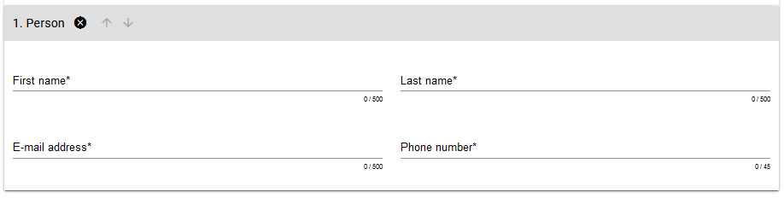

|  |  |  |
| --- | --- | --- |
| **Field name** | **Field type** | **Manner of completion** |
| First name* | text | Specify the first name of the contact person. |
| Last name* | text | Specify the last name of the contact person. |
| E-mail address* | text | Specify the e-mail address of the contact person. |
| Phone number* | text | Enter the phone number of the contact person. |

# Section III *Project indicators*

When you select Section III for editing, the following screen will be displayed.

The screen will have two tables - "Output indicators" and "Result indicators":

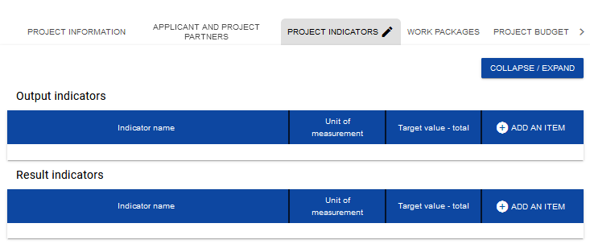

After you click "+" in the ***Add an item*** column (either in Output indicators or Result indicators), the following window with a field to select will be displayed:

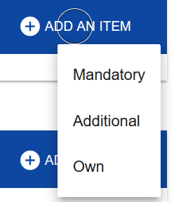

**Note!**

* **In the WOD2021 System all project’s indicators for Interreg NEXT Poland–Ukraine 2021-2027 Programme are placed in the section ‘*Additional’* indicators.**

Project Partners **must** choose indicators for their project **only** from the drop-down list of indicators (according to the Annex 3 the Programme Manual). No other indicator(s) can be included in the project.

The full list of indicators applied in the Programme (see Table 1, Annex 3 to the Programme Manual) is divided into the Programme’s indicators (col. “d”, in WOD2021 the name of the indicator starts with “**MAIN**” word) – crucial for confirming the Programme’s performance – these are the indicators which projects shall address primarily and additional indicators (col. “e”), which shall enable projects more detailed reflection of their expected impact.

In order for the project to be eligible it **must truly** contribute to **at least one** of the Programme’s **output** and **one result** indicators (col. “d”). Indicators from the col. “e” are optional.

* Please select also ‘*Mandatory’* indicator ‘*Interreg – technical indicator’* or ‘*Not applicable’*. It is technical indicator requested by the system, you **should not include** this indicator in you project description.
* *‘Own’* indicators **should not** be defined in WOD. Please do not add any of ‘*Own’* indicators to your Application form. Assessors will not take into account those indicators during project assessment.

After you add a new item for a given indicator type, the following window with fillable fields will be displayed:

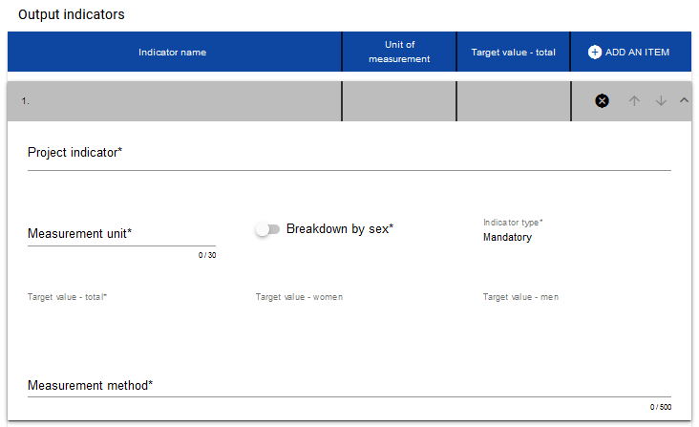

Below you can find descriptions of the fields which must be filled in when creating Section III of a new Application form.

|  |  |  |
| --- | --- | --- |
| **Field name** | **Field type** | **Manner of completion** |
| **Project indicator list** | **list of objects** | **Indicators are added by clicking the "+" icon on the list title and deleted by clicking the "x" icon on the title of the indicator concerned.** |
| Project indicator* | list of values or text | The list of values that can be selected comes from the dictionary of indicators corresponding to the specific objective under which your application form is being created. |
| Measurement unit* | list of values or text | The measurement unit is predefined to the selected Programme indicator and the field is non-editable. |
| Breakdown by sex* | logical variable | This field should remain empty. Indicators in Interreg programmes are not presented in the breakdown by sex. |
| Target value - women | integer | Not applicable. |
| Target value - men | integer | Not applicable. |
| Target value - total* | integer | Please specify the target value planned to be achieved in the project (note that the baseline value for output indictors is always **0**). |
| Measurement method*  (*max 500 characters*) | text | Please briefly describe how you will measure the value of the indicator achieved in the project.  Please note that metrics of each Programme indicator are specified in the Annex 3 to the Programme Manual. |

**Result indicators.**

Please follow the instructions for output indicators.

Please note that for result indicators the baseline value should be **0**. The exception (could be **>=0**) – RCR72 Annual users of new or modernised e-health care services (SO 2.1).

# Section IV *Work packages*

Section IV can be edited only when Section I has been filled in, for it contains the project start and end dates. To define individual tasks, it is necessary to know the timeframe of the project implementation, as the timeframes of individual tasks must fall within it.

After you select Section IV for editing, the following screen with defined (collapsed) tasks will be displayed:

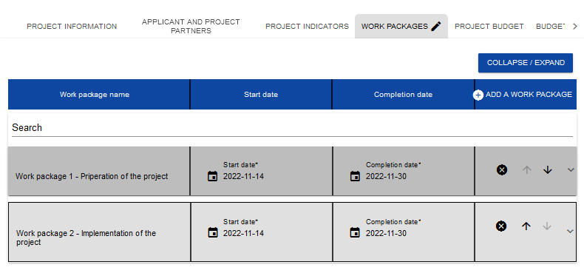

After clicking "+" in the work package table's heading, or in the bottom right corner of the screen if that bar is not visible, the first row of the work package table will be displayed in the collapsed form:

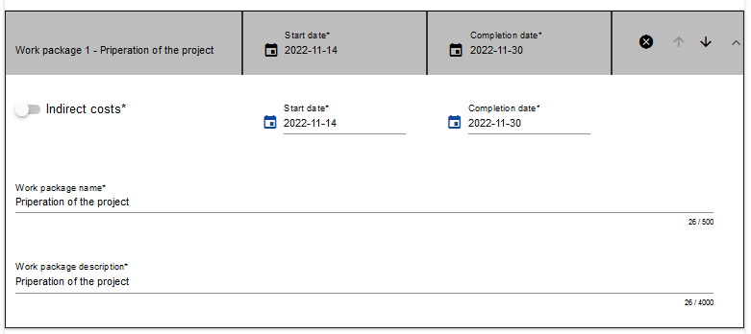

Below you can find descriptions of the fields which must be filled in when creating Section IV of a new Application form. The required fields are marked with an asterisk.

|  |  |  |
| --- | --- | --- |
| **Field name** | **Field type** | **Manner of completion** |
| **Work package** | **list of objects** | **Tasks are added by clicking the "+" icon on the list title and deleted by clicking the "x" icon on the title of the task concerned.** |
| Number | integer | This value is filled in automatically. |
| Work package name*  (*max 500 characters*) | text | Specify the name of the work package to indicate its subject. |
| Work package description*  (*max 500 characters*) | text | In this field, provide a more detailed description of the subject of the work package. Justify why this work package is necessary for the achievement of your project's objective. |
| Start date* | date | Select the year, month and day of the work package start from the calendar. It cannot be earlier than the project start date. |
| Completion date* | date | Select the year, month and day of the work package end from the calendar. It cannot be later than the project end date. |
| Indirect costs* | logical variable | Select it **only for** a work package covering the **flat rate** (for Staff costs, Office and administration and Travel and accommodation) |

**Note!**

When compiling a list of tasks for your project, consider the following guidelines:

* ***One* task within an Application form should be marked as *indirect costs (obligatory for all projects)*. The name of that task is always "Indirect costs". Within this task all costs related to project management (Staff, Travel and accommodation, Office and administration) should be presented.**

Tasks can be expanded or collapsed by clicking the grey task bar.

The icons in the last column have the following functions:

 is used for deleting the task,  are used for changing the order of the tasks in the table (they are not displayed in *Indirect costs* because this item is always at the end of the table).

# Section V *Project budget*

Section V can be edited only when Sections II and IV have been filled in. This is so because the budget is task-oriented, i.e. all budget items refer to the tasks defined in Section IV. Furthermore, each budget item is carried out by either the Applicant or one of the Project Partners defined in Section II – there are no shared budget items.

You can fill in the project budget directly in the system or with the use of an .xlsx template exported from the system. Filling in the budget directly in the system will require you to calculate co-financing amounts for every budget item **by yourself** and calculate flat rates for the Staff, Office and administration and Travel and accommodation separately for each Partner.

Due to the foregoing, we recommend exporting the budget template to an .xlsx file and proceeding in accordance with the instruction provided in Section 1.2.5.2.

**Note!**

* **project budget should be established in EUR;**
* **project budget must cover all eligible costs of the project, not just the EU contribution;**
* **items should be specified for each Project Partner separately;**
* **items in the Staff costs should be aggregated on the level of the Project Partner in each Work package (only one item Staff cost for each Project Partner separately under the Work package Indirect costs);**
* **items in cost categories Office and administration and Travel and accommodation should be listed for each Project Partner separately under the Work package Indirect costs (aggregated for each Project Partner as the % of the Staff costs);**
* **items in the cost categories External expertise and services, Equipment and Infrastructure and works should be specified in detail. I.e. instead of adding total External expertise costs in a Work package each cost item has to be specified separately (e.g. external expert for organizing workshops, preparing studies, etc.);**
* **the limit for the field ‘Cost name’ (including justification) is 500 characters. In that field, except for the cost name, please provide also its description, providing necessary details and justifying that expenditure. IT IS IMPORTANT – basing on that information the assessors will assess your budget. Scarce information will likely lead to a failure of your project.**
* **maximum number of budget lines (combination of cost categories and cost name for all Project Partners) – 400;**
* **more information on project budget could be found in Programme Manual (p. 10. Project budget).**

# Filling in the *Project budget* directly in the system

When you select Section V for editing, the following screen will be displayed containing all tasks previously defined in Section IV and the related budget items in the extended form.

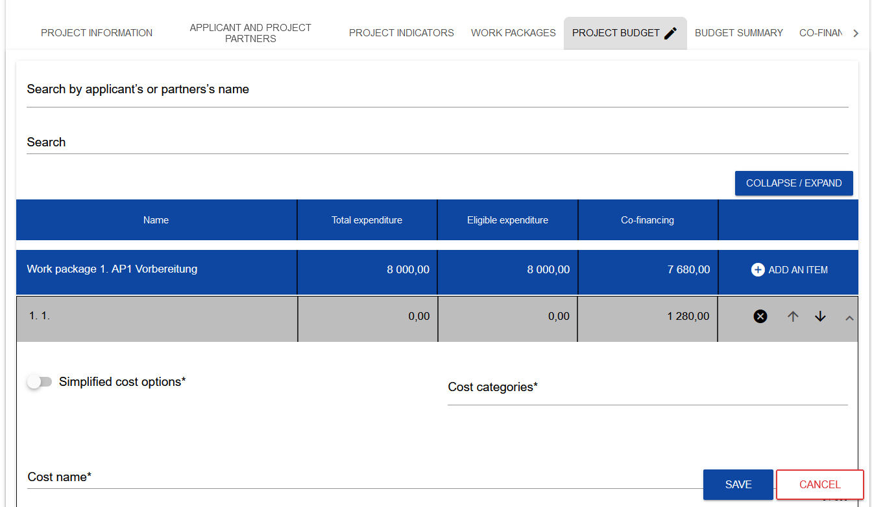

The budget item lines can be extended and collapsed by clicking their grey bars with the name and cost summary.

Each task has the following fields:

|  |  |  |
| --- | --- | --- |
| **Field name** | **Field type** | **Manner of completion** |
| Name | text | The name of the task taken automatically from Section IV. |
| Total expenditure | number (2 decimal places) | The sum of all ***Total value*** fields in the budget items within the task. It is a calculated non-editable value; it equals 0 at the start of editing. |
| Eligible expenditures | number (2 decimal places) | The sum of all ***Eligible expenditures*** fields in the budget items within the task. It is a calculated non-editable value; it equals 0 at the start of editing. |
| Co-financing | number (2 decimal places) | The sum of all ***Co-financing*** fields in the budget items within the task. It is a calculated non-editable value; it equals 0 at the start of editing. |

To create a budget item in a selected task, click the icon  in the last column of that task. A new budget item will be displayed in the expanded form as follows:

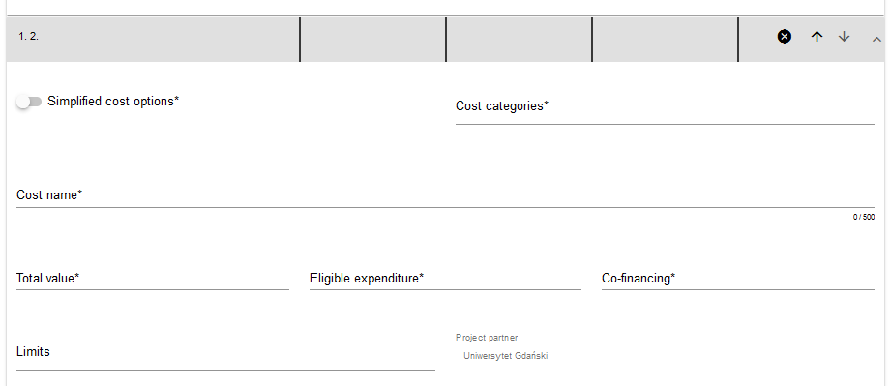

**Description of budget item fields which must be filled in when creating Section V of a new Application form for *actually incurred expenditures***. The required fields are marked with an asterisk.

|  |  |  |
| --- | --- | --- |
| **Field name** | **Field type** | **Manner of completion** |
| **List of budget items** | **list of objects** | **Individual budget items are added by clicking the "+" icon on the list title and deleted by clicking the "x" icon on the title of the budget item concerned.** |
| Simplified cost options* | logical variable | If the expenditure is to be settled as an actually incurred expenditure, this option should remain unmarked. Then, you need to fill in the fields shown in the table below.  Simplified cost options should be marked **only** under dedicated Work packages: Indirect costs – flat rate for Staff costs, Office and administration and Travel and accommodation. |
| Cost categories* | list of values | Select the relevant Cost Category from the drop-down list **only for**:   * External expertise and services, * Equipment, * Infrastructure and works. |
| Cost name*  (*max 500 characters*) | text | Describe briefly the cost item concerned. Individual cost names must be unique within the Work package and Partner. |
| Project Partner* | list of values | Select the Partner whom the budget item concerns (who will incur expenditures under it). The list includes the names of the Lead Partner and Project Partners defined in Section II "Applicant and Project Partners". |
| Total value* | number (2 decimal places) | The total value of the budget item. **Total value must be equal to eligible expenditures**. This value is entered manually. |
| Eligible expenditures* | number (2 decimal places) | This value is entered manually. |
| Co-financing* | number (2 decimal places) | Enter the value of co-financing calculated as the maximum of 90% of eligible expenditures. The value of co-financing cannot be greater than the value of eligible expenditures for the budget item concerned. **The field is not filled in automatically.** |
| Limits | list of values | Select one or more expenditure limits from the list depending on whether the expenditures incurred under the budget item will be related with the limit concerned (e.g. *de minimis aid*). |

**Description of budget item fields which must be filled in when creating Section V of a new Application form for simplified cost options – a flat rate.** The required fields are marked with an asterisk.

**Note!**

* **All flat rates in the project should be displayed in a separate work package (Indirect costs) and calculated in aggregate on the expenditures of a given Partner! *Flat rates should not be a part of thematic tasks*.**

|  |  |  |
| --- | --- | --- |
| **Field name** | **Field type** | **Manner of completion** |
| **List of budget items** | **list of objects** | **Individual budget items are added by clicking the "+" icon on the list title and deleted by clicking the "x" icon on the title of the budget item concerned.** |
| Simplified cost options* | logical variable | Mark that the budget item concerned will be settled with a simplified method (**only** for Staff costs, Office and administration and Travel and accommodation). |
| Simplified cost option type* | list of values | This field appears in the place of *Cost categories*. You can choose from three values: lump sum amount, unit rate and flat rate. **Choose the flat rate.** |
| Cost name* | list of values | The list includes flat rate names defined in the system. |
| Flat rate* | number (2 decimal places) | This field is non-editable and populated with the flat rate value entered in "Cost name". |
| Project Partner* | list of values | Select the partner whom the budget item concerns (who will incur expenditures under it). The list includes the names of the Lead Partner and Project Partners defined in Section II "Applicant and Project Partners". |
| Total value* | number (2 decimal places) | The total value of the budget item. For each flat rate, the total value is initiated as the product of the flat rate percentage and the sum of all direct costs for specific Project Partner. **Total value must be equal to eligible expenditures.** |
| Eligible expenditures* | number (2 decimal places) | This value is entered manually. |
| Co-financing* | number (2 decimal places) | Enter the value of co-financing calculated as the maximum of 90% of eligible expenditures. The value of co-financing cannot be greater than the value of eligible expenditures for the budget item concerned. **The field is not filled in automatically.** |
| Limits | list of values | Select one or more expenditure limits from the list depending on whether the expenditures incurred under the budget item will be related with the limit concerned (e.g. *de minimis aid*). |

The field ***Search by Applicant's or Partner's name*** is used for displaying, in an expanded form, only those budget items that belong to the budget of a specific Partner. To perform that operation, click the field and select either the Lead Partner or one of the Project Partners:

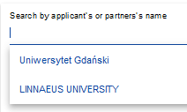

The result will be displayed as follows:

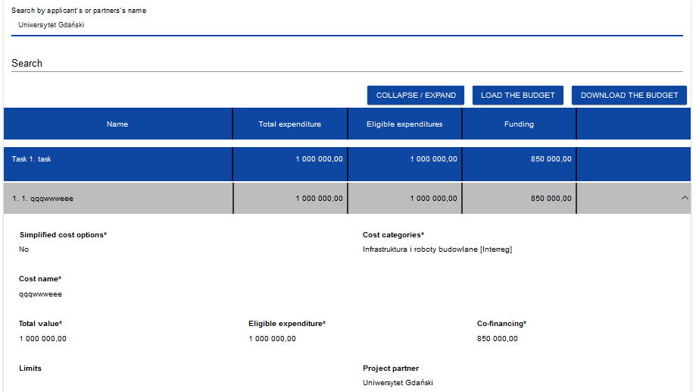

# Filling in the *Project budget* in an .xlsx file template

The budget you have partially or completely filled in in the system can be exported to an Excel file. You can also carry out the entire budget filling operation in an Excel file and next upload it to Section V of your application form.

To this end, go to Section V and, before you start editing, ***Download the budget*** or ***Load the budget*** by clicking the corresponding buttons:

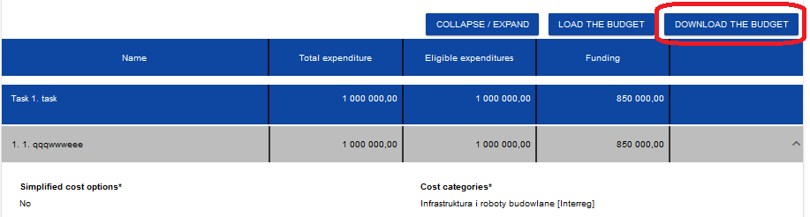

Selecting ***Download the budget*** will create an Excel file with data corresponding to your project. The file will contain the names of tasks and partners as provided in your application form. The file will also contain cost category and simplified cost option names that are allowed in the call concerned.

**Note!**

* **When filling in your budget in an xlsx file, follow the guidelines regarding populating individual fields laid out in Section 1.2.5.1.**

**Instruction for filling in a budget in an .xlsx file:**

1. After selecting *Download the budget* and exporting the file, save it on your computer's hard drive. Open the file. It contains the following tabs and columns:
   1. ***Budget*** tab
   * *Item number* column
   * *Work package* column
   * *Simplified cost options* column
   * *Cost category* column
   * *Cost name* column
   * *Simplified cost options type* column
   * *Simplified cost options name* column
   * *Rate value* column
   * *Number of units* column
   * *Total for unit cost* column
   * *Total value* column
   * *Eligible expenditures* column
   * *Co-financing* column
   * *Project partner* column
   1. ***Limits*** tab
   * *Item* column
   * *Limit* column
   1. ***Indicators*** tab
   * *Item* column
   * *Indicator name* column
   * *Value* column
2. First, enter all budget items to be settled as actually incurred expenditures – ones for which the option selected in Column C "Simplified cost options" is "NO". For each of those items, enter total expenditures and eligible expenditures (K and L), and next, in Column N, indicate the partner that will incur the expenditures under this budget item.
3. After entering all expenditures settled as direct costs, in further items enter the expenditures settled on a flat-rate basis in accordance with the programme rules.

**Note!**

* **When filling in the budget in the .xlsx file, you cannot change the file structure or column names.**

1. Proceeding to the *Limits* and *Indicators* tabs, you can indicate for which budget items a limit is to be added, and for which lump sums an indicator is to be added.

After you have filled in the Excel file, when the budget is complete, click ***Load the budget*** in Section V***.*** Clicking ***Load the budget*** will open a window in which you can select an appropriate Excel file with your budget. When the file is selected, the values contained therein are transferred to the corresponding budget items in respective tasks.

If needed, you can modify your budget. You can re-load the updated xlsx file with your budget to the system by clicking ***Load the budget.*** This will update the data stored in the system.

# Section VI *Budget summary*

When you select Section VI, the following screen will be displayed:

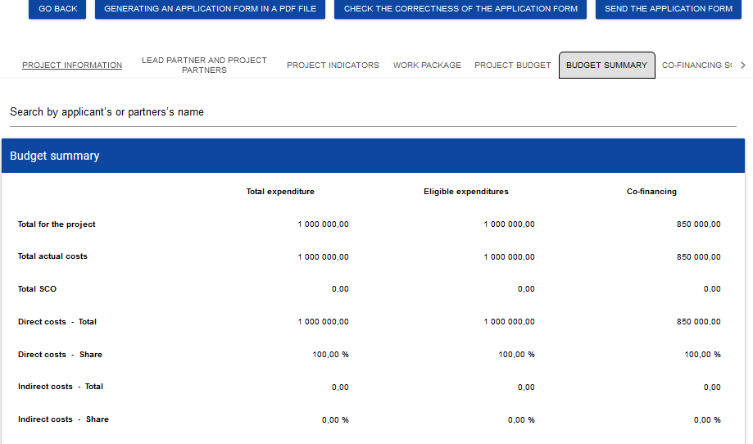

Since the information displayed here is only a summary of the budget created in Section V, this section is non-editable.

This section consists of the following panels:

* ***Budget summary*** – the data referring to al budget items
* ***Cost categories*** – the data referring only to the budget items which belong to a specific cost category
* ***Limits*** – the data referring only to those budget items which are subject to a specific limit

Each panel contains the following items:

* ***Total for the project*** – the sum of the values of all task budgets in the project
* ***Total actual costs*** – the sum of the values of all project budget items not marked as simplified cost options
* ***Total SCO*** – the sum of the values of all project budget items marked as simplified cost options
* ***Direct costs - Total*** – the sum of the values of all budget tasks not marked as indirect costs under the project
* ***Direct costs - Share*** – the % share of the sum of the values of all budget tasks not marked as indirect costs under the project in "Total for the project"
* ***Indirect costs - Total*** – the value of the task "Indirect costs"
* ***Indirect costs - Share*** – the % share of the value of "Indirect costs" in the value of "Total for the project"

The names of cost categories and limits appear in the form of a grey bar above each reported cost category and/or limit.

Each panel item contains the following fields:

|  |  |  |
| --- | --- | --- |
| **Field name** | **Field type** | **Manner of completion** |
| Total value | number (2 decimal places) | The total value of the item. |
| Eligible expenditures | number (2 decimal places) | The value of the item referring only to eligible expenditures. |
| Co-financing | number (2 decimal places) | The value of the item referring only to co-financing. |

The field ***Search by applicant's or partner's name*** is used for displaying the budget summary for a specific partner. If you want to filter the data, select either the Lead Partner or one of the project partners in this field.

After you have selected the desired partner, the budget summary will be displayed referring to that partner only.

# Section VII *Co-financing sources*

Section VII can be edited only when Sections II, IV and V have been already filled in.

When you select Section VII for editing, the following screen will be displayed:

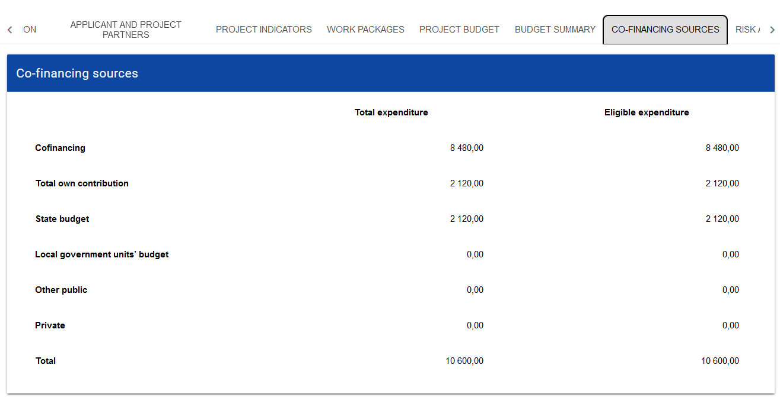

Below you can find descriptions of the fields which must be filled in when creating Section VII of a new Application form

|  |  |  |
| --- | --- | --- |
| **Field name** | **Field type** | **Manner of completion** |
| Co-financing/Total expenditures* | number (2 decimal places) | Specify the amount of co-financing.  **Note!**   * **The value should be equal to the total amount of co-financing in the project shown in Section VI *Budget summary* (maximum of 90%)** |
| Co-financing / Eligible expenditures* | number (2 decimal places) | Specify the amount of co-financing  **Note!**   * **The value should be equal to the total amount of co-financing in the project shown in Section VI *Budget summary* (maximum of 90%)** |
| Total own contribution / Total expenditures | number (2 decimal places) | This field is non-editable and represents the sum of all expenditures on own contribution. The amount should be equal or greater than 10% of the project’s total budget (for each Project Partner). |
| Total own contribution / Eligible expenditures | number (2 decimal places) | This field is non-editable and represents the sum of all eligible expenditures on own contribution. The amount should be equal or greater than 10% of the project’s total budget (for each Project Partner). |
| State budget / Total expenditures* | number (2 decimal places) | Specify the value of **state budget** funding which will be allocated to financing all expenditures under the project. |
| State budget / Eligible expenditures* | number (2 decimal places) | Specify the value of **state budget** funding which will be allocated to financing eligible expenditures under the project. |
| Local government units' budget / Total expenditures* | number (2 decimal places) | Specify the value of funding from local government units which will be allocated to financing all expenditures under the project. |
| Local government units' budget / Eligible expenditures* | number (2 decimal places) | Specify the value of funding from local government units which will be allocated to financing all expenditures under the project. |
| Other public / Total expenditures* | number (2 decimal places) | Specify the value of other public funding which will be allocated to financing all expenditures under the project. |
| Other public / Eligible expenditures* | number (2 decimal places) | Specify the amount of other public funding which will be allocated to financing eligible expenditures under the project. |
| Private/ Total expenditures* | number (2 decimal places) | Specify the value of private funding which will be allocated to financing all expenditures under the project. |
| Private/ Eligible expenditures* | number (2 decimal places) | Specify the amount of private funding which will be allocated to financing eligible expenditures under the project. |
| Total/ Total expenditures | number (2 decimal places) | This field is non-editable and represents the sum of all expenditures.  **Note!**   * ***Total expenditures* must be consistent with *Total expenditures* shown in Section VI *Budget summary*.** |
| Total/ Eligible expenditures | number (2 decimal places) | This field is non-editable and represents the sum of all eligible expenditures.  **Note!**   * ***Eligible expenditures* must be consistent with *Eligible expenditures* shown in Section VI *Budget summary*.** |

If there are any inconsistencies, an error message will be displayed when saving the data entered and/or updated in Section VII.

# Section VIII *Risk analysis*

When you select Section VIII for editing, the following screen will be displayed:

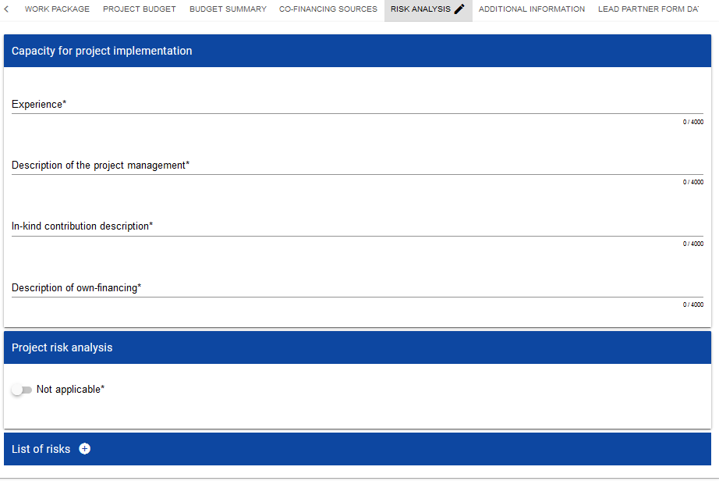

Below you can find descriptions of the fields which must be filled in when creating Section VIII of a new Application form

|  |  |  |
| --- | --- | --- |
| **Field name** | **Field type** | **Manner of completion** |
| Experience*  (*max 4000 characters*) | text | Please describe briefly:  - experience of each project partner in participating in and/or managing EU co-financed projects or other international projects over the past three years;  - motivation to participate in the project of each Partner;  - indicate project partners which participate for the first time in the Programme. |
| Description of the project management*  (*max 4000 characters*) | text | Please describe briefly:  - How the project will be managed;  - Each partner’s management experience;  - Management capacities (number of employees, available management resources (office, equipment etc.). |
| Description of in-kind contribution* | text | Please provide ‘Not applicable’ |
| Description of own-financing* | text | Within the Programme each Project Partner may receive up to 90% co-financing for eligible expenditures generated within a project. The remaining part of the costs has to be contributed by the partners from their resources.  Thus, please describe your main sources of financing as well as your financial capacity (for each Project Partner) to ensure the own contribution for project implementation. |
| Project risk analysis – not applicable | logical variable | Please **do not** mark ‘Not applicable”. |

Please proceed to filling in the risk table. When you click "+" on the ***List of risks*** bar, the following window with will be displayed:

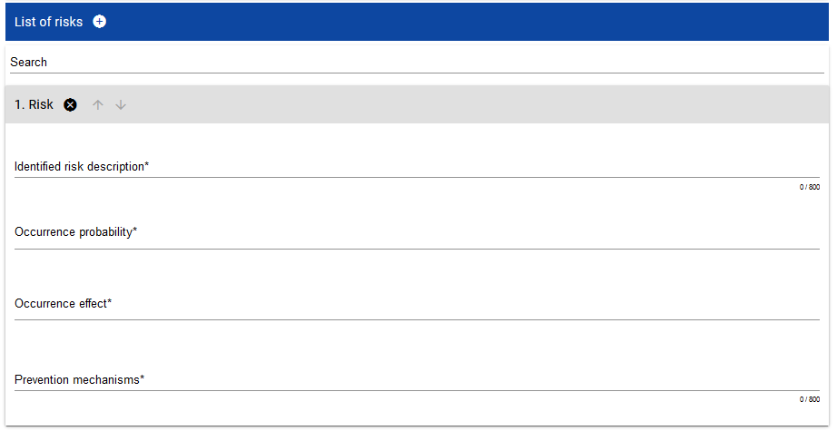

Description of the fields which must be filled in when creating Section VIII of a new Application form if a risk analysis is attached

|  |  |  |
| --- | --- | --- |
| **Field name** | **Field type** | **Manner of completion** |
| **List of risks** | **list of objects** | **It is editable only when the project is subject to risk analysis. Risks are added by clicking the "+" icon on the list title and deleted by clicking the "x" icon on the title of the risk concerned.** |
| Identified risk description*  (*max 800 characters*) | text | Please, identify the risks – threats (i.e. human, operational, procedural, financial, technical, natural, and political) for successful project implementation – you need to answer the question: what can happen? (i.e., what can go wrong?). |
| Occurrence probability* | list of values | How likely is it that it will happen?Select the risk level value from the list. |
| Occurrence effect* | list of values | From the list, select the value that defines the effect brought by the described risk. |
| Prevention mechanisms*  (*max 800 characters*) | text | Briefly describe control mechanisms which you intend to deploy to mitigate the described risk.  What can be done to avoid the risks and if they do occur how will they be handled? |

# Section IX *Additional information*

When you select Section IX for editing, the following screen with additional fields will be displayed. The range of the fields may differ depending on the call. They can be text fields, numeric fields, dates or selection fields where you can select one or more values from a list.

For instance, this section can have the following form:

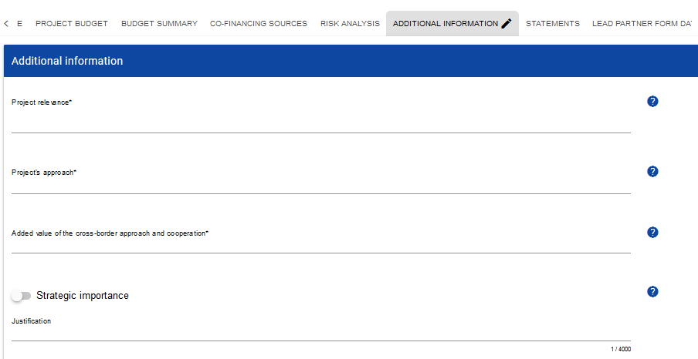

Next to each field there are icons with contextual information regarding their format and meaning. Some of those fields may be obligatory.

Description of the fields in Section IX of the Application form:

|  |  |  |
| --- | --- | --- |
| **Field name** | **Field type** | **Manner of completion** |
| Project title in Polish/ Ukrainian*  (*max 500 characters*) | text | Please provide a Project title in Polish/ Ukrainian. |
| Project acronym*  (*max 15 characters*) | text | Please provide a short text, easy to remember, that reflects the main focus of the project.  For more on acronyms and their examples see Annex 4. Communication Guide for the Project Partners. |
| Project type* | list of values | Please tick the adequate field. |
| Provide a brief analysis of the problem(s), need(s), challenge(s) justifying the project*  (*max 4000 characters*) | text | Please provide a brief analysis of the problem(s), need(s), challenge(s) justifying the project:   * Clearly identify specific problems or challenges in the Programme area to be addressed by the project; * Refer to target groups and final beneficiaries; * If possible, support your statements with statistical information and concrete examples. |
| Objectives of the project*  (*max 4000 characters*) | text | * Please indicate one overall objective which relates to common interest and to which the project aims to contribute. * The overall objective shall clearly link to selected Programme priority and specific objective. * Please indicate max three specific objectives of the project that will lead to achievement of the overall objective. |
| Describe the relevance of the project to the Programme/priority/specific objective selected*  (*max 4000 characters*) | text | Please refer the relevance of the project (its objectives, expected outputs and results) and proposed approach to:   1. identified problem(s), 2. selected priority and specific objective of the Programme, 3. Programme strategy – description of the problem addressed. |
| Demonstrate the cross-border impact of the project*  (*max 4000 characters*) | text | 1. What cross-border impact will the project bring to both sides of the border (project partners, target groups, Programme area)? 2. Why it is important to implement the project in the proposed cross-border partnership? Cannot the result be achieved without cooperation within the Programme? 3. Will the project create a basis to develop the current/future cross-border cooperation? |
| Activities, costs and partners outside the Programme area (if applicable)  (*max 4000 characters*) | text | 1. Please describe and justify any of project activities which is planned to be implemented outside the Programme area. 2. In addition, please specify the total cost (in EUR and in % of the total project budget) to be incurred outside the Programme area, if any. 3. In case any of (Lead) partners is registered outside the Programme area, please indicate it and justify the need for participation of such organization in the project. |
| Partnership and scope of cooperation*  (*max 4000 characters*) | text | Please describe:   1. the composition of partnership that will implement the project; 2. the role and participation in the project of each partner; 3. Please, describe the intensity of each cooperation level:    1. joint project preparation (**obligatory**)    2. joint project implementation (**obligatory**)    3. joint project staff and joint project financing (**at least one obligatory**) |
| Durability of the project*  (*max 4000 characters*) | text | 1. Please, describe the long-lasting impact that your project will have on its target groups. How will the project main outputs be further used once the project has ended? 2. Please outline the scope for replication and extension of the outcome of the project, if applicable. 3. Explain how durability of the project’s results will be secured after completion of the project (financial and institutional durability). |
| Complementarity with other actions, projects, initiatives*  (*max 4000 characters*) | text | Please specify whether:   * synergies/complementarity are ensured between the project and other initiatives in this field and describe in what way exactly; * results of other initiatives are used in the project and will be further developed/strengthen; * your project is part or is interrelated with other actions/projects; * results/products of the project are complementary to results/products of other initiatives in the field. * If yes, please describe the methods of division of tasks/activities to be to be financed and implemented under each of the projects. |
| Project contribution to horizontal principles*  (*max 4000 characters*) | text | Please, describe the project impact on horizontal principles:   * the principle of equal opportunities, non-discrimination[1], accessibility for persons with disabilities; * equality between women and men. |
| Sustainable development principle and DNSH*  (*max 4000 characters*) | text | Please specify in what way project fulfils and respect the sustainable development principle and is in line with the "do no significant harm" (DNSH) rule.  Please refer to all stages of the project implementation – its preparation, implementation and completion. |
| State aid  (*max 500 characters*) | text | Does the project include expenditure which shall be reported as State aid? Please justify your answer. |
| Revenues*  (*max 500 characters*) | text | Does the project generate revenues? If yes, please provide a brief description/explanation. |
| Readiness*  (*max 500 characters*) | text | Is your project ready for implementation? Do the Partners possess the documents necessary for the start of the implementation? |

# Section X *Statements*

The Section X is not applicable for the 1st Call for proposals.

# Section XI *Appendices*

If you select Section XI for editing, a screen will be displayed with appendices included in the application form attached to the call for which your application form has been created.

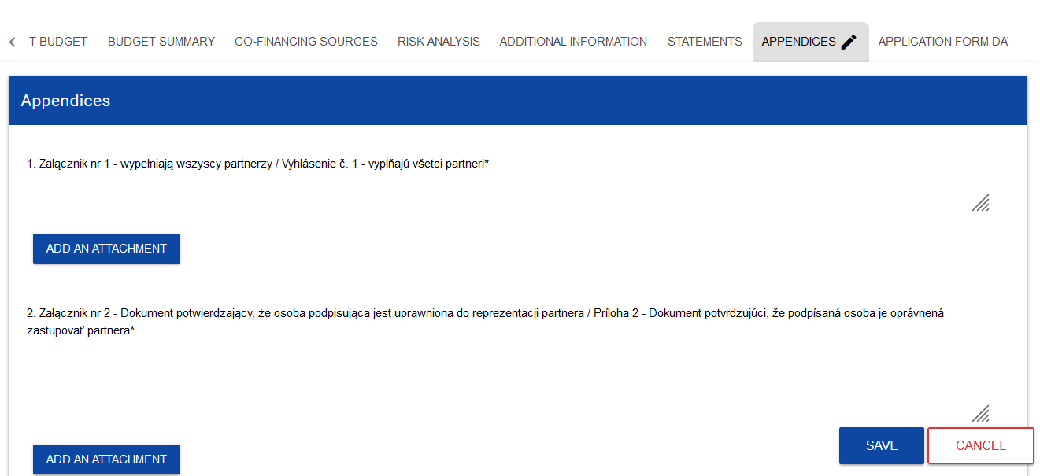

**Note!**

* **An attachment marked in the system as optional may be obligatory for certain types of entities, projects, tasks, project settlements etc. So it may not apply to all applicants or projects, but it may apply to your project. You should therefore very carefully analyse the list of appendices to the Application form published with the call notice.**
* **The maximum size of the attachment is *25 MB***

To add an appendix, click ***Add an attachment*** below the name of a relevant appendix. A standard File Explorer window will be displayed for you to select the appropriate document.

The selected appendix is visible in the field below the appendix name in the form of a file name.

If you want to change the attached appendix, click **Add an *attachment*** again and select a new file. The selected file will replace the previous one.

Each Application form should be provided with the following supporting documents (detailed description of the documents required you can find in p. 6.1.3 of the Programme Manual):

1. **Annex A1.** Communication plan – **obligatory**
2. **Annex A2.** Lead Partner’s declaration – **obligatory**
3. **Annex A3.** Partnership statement of Project Partners – **obligatory**
4. **Annex A4.** Statutes or other relevant documents – **applicable only for non-public institutions**
5. **Annex A5.** Copies of the profit and loss account and the balance sheets – **applicable only for non-public institutions**
6. **Annex A6.** Authorisation from the Lead Partner/Project Partner that the person has the right to sign the declarations and statements to be annexed to the Application form – **if applicable**
7. **Annex A7.** The Lead Partner’s declaration on ensuring the funds necessary for project implementation – **obligatory**
8. **Annex A8.** Register document applicable for the Lead Partner/Project Partners – **obligatory**
9. **Annex A9.** Declaration of the Lead Partner/Project Partner of Compliance with the Charter of Fundamental Rights – **obligatory**
10. **Annex A10.** A self-declaration on the building permission – **applicable only for infrastructural projects**
11. **Annex A11.** Declaration of the Lead Partner/Project Partner on the right for the land/real estate disposal for the construction/supplies purposes – **applicable** **for all investment and infrastructural projects**
12. **Annex A12.** Decyzja o środowiskowych uwarunkowaniach (for Polish Partners) or Environmental Impact Assessment (EIA) according to the national legislation is force, as the part of Technical Documentation according to National Construction Standard (for Ukrainian Partners) – **applicable only for infrastructural projects**
13. **Annex A13.** Declaration of the Lead Partner/Project Partners on maintaining the projects results and objectives for at least five years after project completion – **applicable** **for all investment and infrastructural projects**
14. **Annex A14.** Assessment of expected impacts of climate change – **applicable only for projects including an infrastructure component of at least 1 million EUR**
15. **Annex A15.** Other necessary documents required by Polish/Ukrainian law
16. **Annex A16.** State aid form – **if applicable**
17. **Annex A17.** De minimis aid form – **if applicable**
18. **Annex A19.** Full feasibility study – **if applicable**
19. **Annex A20.** Other necessary documents required by Polish/Ukrainian law – **if applicable**
20. **Annex A18.** Declaration on de minimis aid for Polish Partners – **if applicable**

# Section XII *Application form data*

When you select Section XII for editing, the following screen will be displayed:

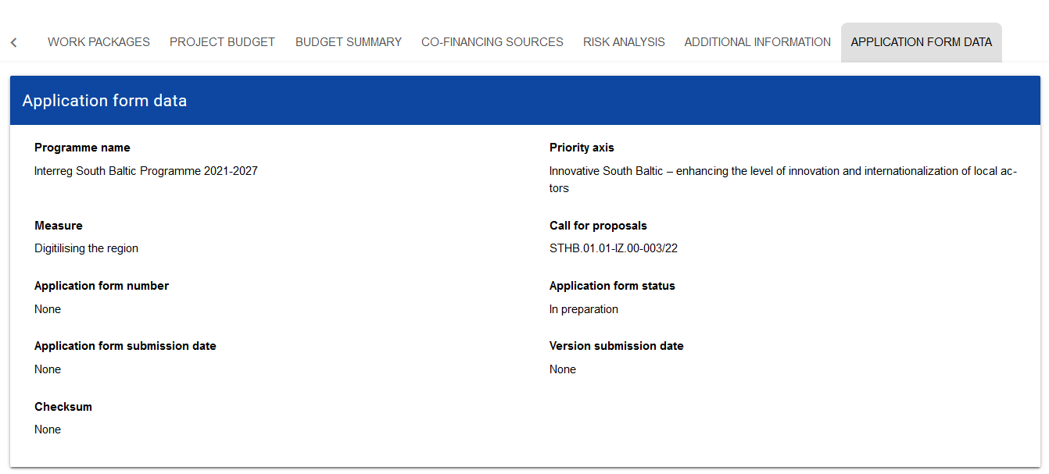

The information displayed here is a summary of the application form.

This section is non-editable.

Description of the fields in Section XII of the application form

|  |  |  |
| --- | --- | --- |
| **Field name** | **Field type** | **Manner of completion** |
| Operational programme | text | The name of the programme under which the application form has been created. |
| Priority axis | text | The Priority under which the application form has been created. |
| Measure | text | The Specific objective under which the application form has been created. |
| Call number | text | The number of the call under which the application form has been created. |
| Application form number | text | The number assigned automatically to the Application form at sending it to the Joint Secretariat. |
| Application form status | text | The current status of the Application form. |
| Application form submission date | date | The date of submission of the Application form. |
| Application form clarification deadline | Time dd:hh:mm | The time remaining for the applicant to clarify the application form. This field is displayed only for the statuses ***To be clarified*** and ***Under clarification***. |
| Version submission date | date | The date of submission of the current version of the Application form. |

# Deleting an Application form

If you resign from submitting your application before sending it to the competent authority, you can delete it from the system. To this end, go to the list of Application forms and select ***Delete*** from the menu of the appropriate application form:

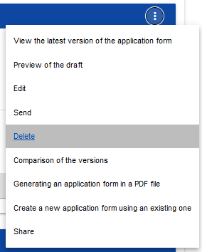

A warning message will be displayed asking you to confirm deleting the Application form:

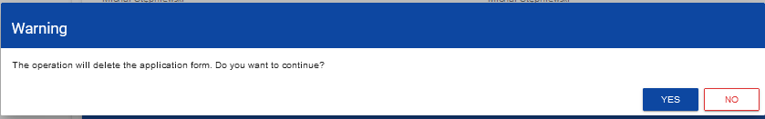

After you confirm the operation, the selected application form will no longer be visible in the application forms viewing screen.

# Sending an Application form for assessment

You can send your Application form for assessment only when it has been successfully checked for correctness in the WOD2021 app (see WOD2021 Manual, General Part, Section VI.6.2.). If this is the case, an authorised user should go to the list of application forms and select ***Send*** from the menu of the appropriate application form:

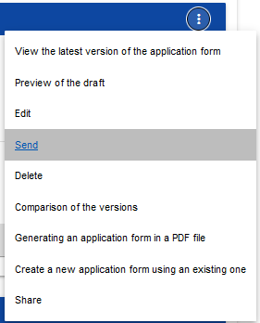

A warning message will be displayed asking you to confirm sending the Application form:

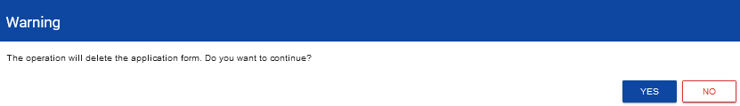

After you confirm the operation, the application form will change its status to ***Sent***. Information will also appear in Section XII including the number assigned automatically to the application form at the moment of sending it for assessment, and the application form submission date. A new official version of the application form will also be created.

**Note!**

* **The system verification of the correctness of the Application form (validation) concerns only whether all mandatory fields have been filled in and whether the validation criteria have been met for the financial data entered in the system (e.g. whether the sum of eligible expenditures is not higher than the sum of total expenditures, or the sum of own contribution and co-financing gives the sum of eligible expenditures etc.). The system validation does not concern e.g. the correctness of your selection of flat or unit costs, calculations of their levels for each partner, whether the information provided in a specific field is complete thematically or whether all appendices required for a specific partner and project have been attached etc. Therefore, before sending your application form, you need to read it carefully and check the data and information provided and appendices attached are consistent with the call documentation, and whether the budget is consistent with the eligibility rules applicable to the Programme.**

# Clarifying an Application form

An applicant can clarify the Application form where the Joint Secretariat sent it back for clarification. The information about the scope of clarification is provided in a message sent by the Joint Secretariat (see Section 2.4).

An application sent for clarification can have the following statuses:

- ***To be clarified***, where the application form has been sent back for clarification, but clarification process has not started yet.

- ***Under clarification,*** where you have started clarifying the application form but you have not re-sent it for assessment.

If you want to clarify your application form, go to the list of application forms and find the application that has been sent back for clarification. Select ***Clarify*** in the menu of that application:

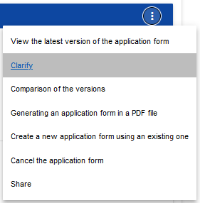

A screen of the application form will be displayed similar to that shown in the case of editing.

**Note!**

* **If you start editing your application form when the template of the application form has changed, a warning will be displayed informing you that the application form you are using is not up to date, and a new version of your application form will be created in the new template**.

From your perspective, clarification means re-editing your application form. However, the modifications entered must be consistent with the recommendations you have received from the Joint Secretariat. After you re-send your application form, the Joint Secretariat will be able to compare the versions and check all modifications you have entered.

After you start editing any section, the clarified application form will change its status ***To be clarified*** to ***Under clarification***.

You must send the clarified application form back to the authority (see Clause 1.4.).

# Cancelling an Application form

If you resign from submitting your Application form after it was sent for assessment, you can cancel it. As a result of cancelling an application form, the Joint Secretariat will no longer deal with it. To this end, go to the list of application forms and select ***Cancel the application form*** from the menu of the appropriate Application form:

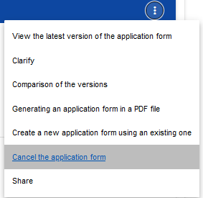

A warning message will be displayed asking you to confirm cancelling the application form:

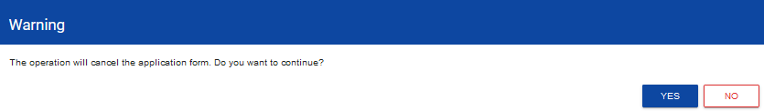

After you confirm the operation, the selected application form will receive the status ***Cancelled***.

# Creating an Application form on the basis of another Application form

Where you intend to submit another application in a specific call, you can create a new application form on the basis of one that already exists in that call. To this end, go to the list of application forms and select ***Create a new application using an existing one*** from the menu of the appropriate Application form:

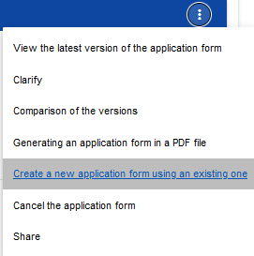

Next, follow the description provided in Section 1.1 ***Creating an Application form***. The only difference is that the fields of such an application form are already populated as in the copied application form. If there have been any changes in the application form template, the newly created application form includes those changes.

# SYSTEM MESSAGES

When working with the WOD2021 app it may happen that the operation of the system is interrupted. It can take place upon a breach of field validation rules, a breach of business rules, a breach of data consistency or in the case of technical errors (e.g. relating with network disturbances).

# FIELD VALIDATION

If you fail to fill in any mandatory fields when saving your application form, the app will display an error message, e.g.

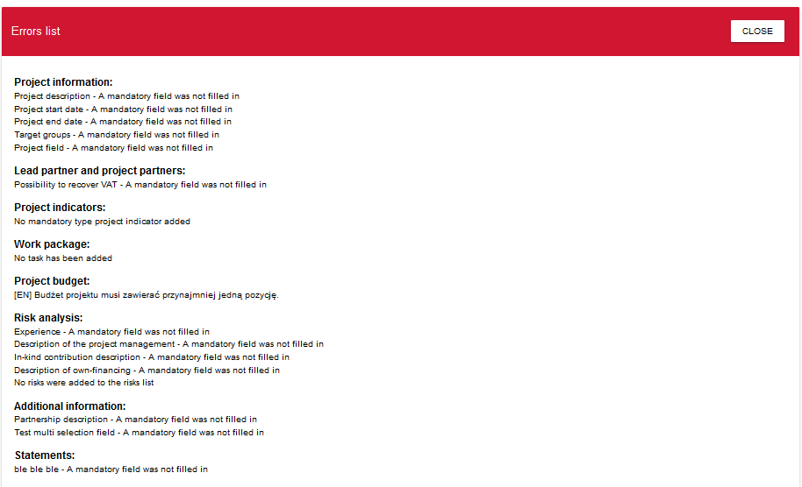

The system will also inform you about fields that were filled in incorrectly during edition of individual sections of the application form, e.g.

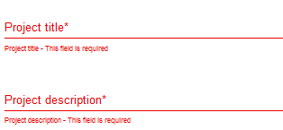

If a field has been filled in inconsistently with its format, the System will highlight it in red and display an error message, e.g.

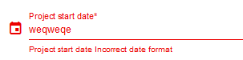

# BUSINESS RULES

If a business rules was breached when saving an object, the app will display an error message.

Business rules implemented in the WOD2021 system may concern either the consistency of data of the object on which an operation is performed or the conditions of performing the operation itself.

# WARNINGS

If a user has run an operation that may entail loss of data or irreversible change of status, the app will display a warning, e.g.

***Example: A warning message at the end of data editing***

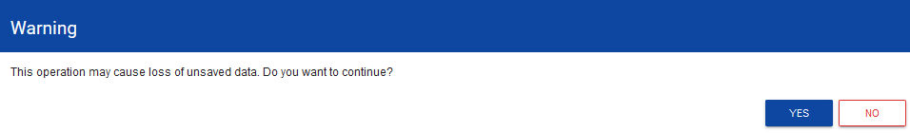

# MESSAGES TO APPLICANTS

Where the circumstance regarding filling in application forms have changed, the applicants concerned will receive special messages. They are available after clicking the icon in the top right corner of the screen:

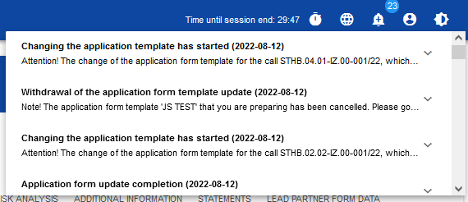

The messages are sent in particular where:

* the Administrator has started changing the application form template in the call under which the applicant's application forms have been created
* the Administrator has completed changing the application form template attached to the call or withdrawn from the changes
* the call supervisor has set or changed the deadline for the applicant to clarify the application form

Each such message concerns a specific application form. Clicking the selected message will expand its full content and display a link allowing you to go to that application form's page:

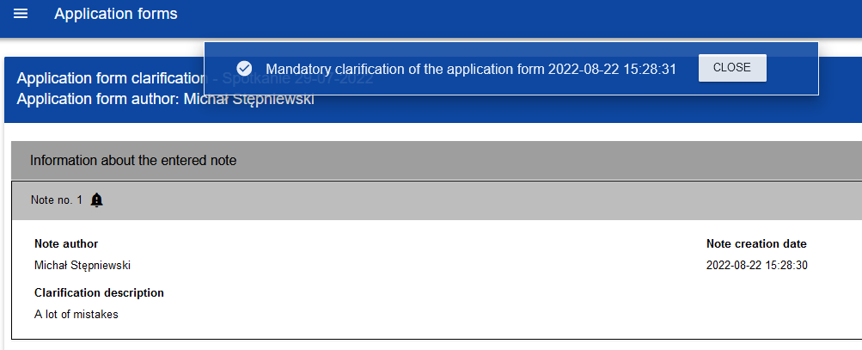

Closing the content of the message will reduce the counter of unread messages shown above the bell icon:

A given message can be marked as read also by clicking OK after expanding it in the list of messages.

1. According to Article 9(3) of Regulation (EU) 2021/1060, the projects with partners representing municipalities that have taken discriminatory measures such as signing the anti-LGBT declarations **cannot be granted**